All-in-the-Hall Report
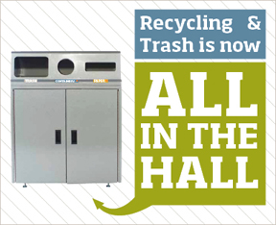
Program Summary
During OSU’s 2014 spring term, a new program was implemented through the collaboration of Campus Recycling, Facilities, GCA, and OSU’s Fire Marshal, as a means to address the large quantities of recyclables found within the trash. Called All-in-the-Hall (AitH), the program introduced recycling options alongside trash to encourage improved recycling habits, as previous programs and studies have shown individuals to be more likely to recycle an item when trash bins were paired with recycling options. Four buildings, each featuring a high volume of students in classrooms and auditoriums, were selected to take part in the pilot program: Cordley, Gilbert, Gilfillan Auditorium, and Weniger. Due to Campus Recycling’s inability to service classroom bins during class periods, trash cans were removed from the selected classrooms within these buildings entirely, and were replaced with three-bin units – made up of a paper recycling, container recycling, and a trash bin - directly outside the rooms. With these actions, the program was created with the goal of increasing the recycling rate by reducing the amount of recyclables found in the trash. A secondary goal of evaluating effective signage was also emplaced, with three different types of informational signage being tested.
Methods
Each week, Campus Recycling’s Student Program Assistant would collect the trash, container recycling, and paper recycling from each of the AitH units. The recycling and waste was then sorted and weighed into what was considered correct, and what was a contaminant for that category. In the beginning, only decals labeling the bins categories was used, but informational wall posters and data posters were implemented in weeks 5 and 8 respectively. Further details on the materials and methodology for the pilot program, as well as examples of the signage used, are documented separately; see the appendix for more details.
Results
Across all buildings, the amount of recyclables found in trash showed a significant drop in comparison to the previous spring term (see figure 1).

Figure 1
The overall recycling rate, which is the percent of total waste collected in AitH units that was recycled, averaged 61.2%. The recycling rate was used to evaluate the different types of signage during the program (see figure 2).

Figure 2
Trash contamination – or the percent (by weight) of recyclable material found in trash bins- averaged 1.5% during AitH. Paper contamination – percent trash found in the paper recycling - averaged at around 3%, while container bin contamination averaged at about 20% (See figure 3). Common contaminants were recorded during audits, with coffee cups and food contaminated items being among the top contaminants in recycling bins. Due to time and scheduling constraints, we were unable to record the contamination in the previous year’s recycle bins.

Figure 3
Total trash capacity was increased to meet or exceed 2013 levels; overall trash capacity across the four buildings increased by 13%. Of this increased capacity, an average of 47% of it by volume was used. Likewise, the recycling capacity was increased in each location - by 357% across all buildings. This additional capacity was utilized; the average volume of paper and container bins used was 33% and 65% respectively. Alongside these increases in capacity, the total number of locations serviced decreased in each building. Trash bins were serviced daily, while recycling was serviced on a weekly basis.
Discussion
With the removal of trash cans within classrooms, in exchange for a pairing of recycling and trash in the hallways, the amount of recyclables found in the trash decreased significantly. Due to scheduling limitations in 2013, we were unable to collect consistent data as we have this term, and were thus unable to accurately compare the recycling rate of this spring term to the last year’s spring term. However, a baseline for future investigations was formed from the recycling and contamination rates, and it is reasonable to conclude that the recycling rate increased due to the decrease of recyclables found in the trash.
A slight increase in the recycling rate was shown following the addition of instructional signage, as well as feedback signs (see figure 2). Recycling rates were highest when direct feedback on recycling rates was provided (i.e. data posters). No correlation was found between the types of signs and the contamination of trash or paper recycling, but a decrease in container contamination can be seen (see figure 3).
Some sources of error in the project arose due to time constraints, such as instances where trash was collected before it could be measured, leading to some data points showing no contamination. Additionally, the calculations for what percent full the bins were, were based on visual estimates, and may have led to additional errors.
The AitH units were well-received by individuals in participating buildings. Slight resistance was received by occupants of classrooms with sinks and paper towels, but once this was addressed by placing small trash cans in cabinets for paper towel disposal, no further concerns were received. Students enjoyed the appearance of the bins, and positive responses were given with the additional recycling capacity.
Recommendations
With the above information in mind, we recommend that the program be expanded into 4-5 additional buildings in fiscal year 2015. This process would remove the trash cans from one or more high-traffic classrooms and/or auditoriums in each building, and a number of the three-bin units, either equivalent or greater to the current trash capacity, would be placed within the halls outside the classrooms. Campus Recycling would request funds from the Pepsi Sustainability Fund to pay for this second installment. We suggest that no additional staff time needs to be committed to collecting further data on this waste collection model. This recommendation is based on our own findings, as well as the successful implementation of this model at Portland State University and Chemeketa Community College.

Appendix A
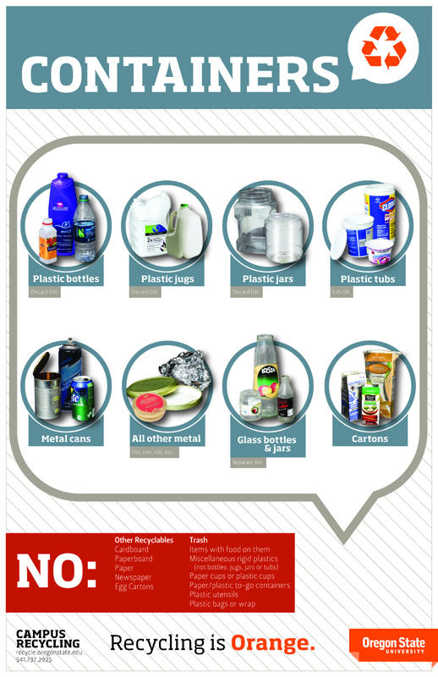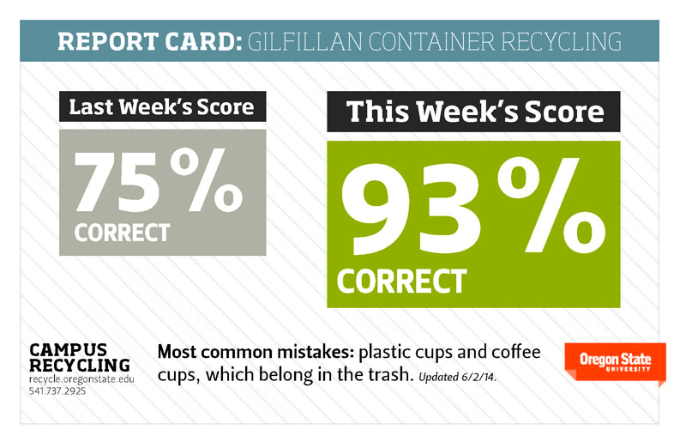
Appendix A – Examples of the three types of signage used during AitH are pictured above. Initially, only decals were used at the opening of each receptacle. During week 5, informational wall posters were added, and in week 8, data posters served as a means of delivering direct feedback to bin users.

Appendix B
Methodology for All-in-the-Hall
The following is information regarding how the Student Program Assistant documented data for the AitH program.

Materials List
- Truck that can hold upwards of twenty 35-gallon bags of recycling and trash
- Two rolls of 35-gallon can liners
- 90 gallon tote
- One roll of blue tape
- A sharpie
- A bag
- A scale with a large surface area (roughly 4X4 feet)
- A fish scale that can weigh up to 70 lbs.
- A notepad
- A pair of dish washing gloves
- A table or some other raised surface
- A small bucket
- A hose
- A mop and its accompanying bucket
- Floor cleaning fluid
- Signage (details outlined later)
Procedure
Computer work to be completed
- A data collection sheet was created.
  - For each hall, there are 7 columns with the following labels: “Week,” “Paper,” “Containers,” “Trash,” “Diversion Rate,” “True Recycle Rate,” and “Signs.”
  - Within “Paper,” “Containers,” and “Trash,” there were three sub-columns called “contamination (lb),” “correct (lb),” and “% contamination.”
  - Under “Containers,” along with the three sub-columns detailed in step 3, there was also a column labeled “% correct.”
  - For each hall, there were 10 rows (labeled 1-10 for Weniger and Cordley and 2-11 for Gilbert and Gilfillan) under the “week” column.
  - For each column labeled “contamination (lb)” or “correct (lb),” data was stored. “Contamination” was reserved for the weight of material that shouldn’t have been in that category while “correct” was the weight of material that should have been there.
  - For the “% contamination” column, an equation was used which takes the weight of the contaminated material (paper, container or trash) and divides that by the combined weight of contaminated and correct material collected for that week in that building.
  - The “% correct” was the complement of “% contamination” (100 - % contamination) and was only included under Containers because it was used for container specific signage.
  - The “Diversion Rate” column used an equation that divides the total weight of diverted material (this included both “contamination” and “correct” material under Paper and Containers) by the total weight of collected material for the week.
  - The “True Recycle Rate” column used an equation that divided the total weight of material that could actually have been recycled (The “correct” material in Paper and Containers) by the total weight of collected material for the week.
  - The “Signs” column kept track of what type of signage was being used during that week of data collection (“Decal only” was used up through week 4. “Wall Posters” is weeks 5-7 and “Data Posters” was used from week 8 to the final week of data collection).
- A spreadsheet detailing the fullness of each bin was created.
  - There was a row for what week the data is being collected.
  - For each week, there were categories for each building being serviced.
  - Under each building name were two columns: a list of each bin being serviced and their respective percentage full measurements.
  - These bins were labeled with their hall name, their category (paper (P), container (C) or trash (T)) and which room number the bin was closest to (ex: GilbP324).
- A spreadsheet regarding common contaminates was created.
  - There was a one column entitled, “Common contaminated items.”
  - Under this were three sections (“Trash,” “Containers,” and “Paper”).
  - For each section there were two sub-columns (“good” and “contamination”). The “good” column was a list of common correct items and the “contamination” column was a list of common contaminates.
- A spreadsheet regarding broken bins was created.
  - There is one column entitled “Bins that Don’t Close”
  - Under this included a list of bins that don’t work or are broken in some way.
  - The bins are identified with the building they’re located in and the building the bin is closest to (ex: W151).
- A summary spreadsheet was created.
  - There were 6 columns in total with the following titles: “Week,” “Paper Contamination,” “Container Contamination,” “Trash Contamination,” “Recycle Rate,” and “Signs.”
  - Each row was marked by the week the data was collected (1-11), and this information went under the “Week” column.
  - The “Paper Contamination” column used an equation that sums the weight of “correct” paper from all of the halls and divided that by the total weight of collected paper from all of the halls for the respective week.
  - The “Container Contamination” and “Trash Contamination” do the same thing as in step c but with their respective material.
  - The “Recycle Rate” used an equation that divided the total weight of correctly recycled paper and containers by the total weight collected for the week for all the halls.
  - The “Signs” column was formatted in the same manner as in step 1j.
  - There were also three graphs: one plotted the “Paper Contamination,” “Container Contamination,” and “Trash Contamination” over time (in weeks), one plotted the “Recycle Rate” over time, and the last one was a double bar graph comparing “Trash Contamination” from 2013 and 2014.
Collecting Material from Buildings
- Fill the bag with the two rolls of can liners, the roll of blue tape, the notepad and the sharpie.
- Place the full bag and the 90 gallon tote inside of the truck.
- Drive the truck to the agreed upon building.
- Unload the bag and tote and take them both inside of the building.
- Go to an “All in the Hall” container and write down how full each bin is inside (paper, containers and trash)
- Remove the contents of each bin and place them into the tote.
- Label each can liner with tape and sharpie detailing the building you’re in and what’s inside the liner (paper, containers or trash).
- Check if the container is functional. If not, write this down identifying the bin using the building name and the classroom number it is closest to (ex: Gilb124).
- Repeat steps 5-8 for each “All in the Hall” container within the hall.
- Every time the tote is full, take it out back to the truck and unload it.
- Once finished with the hall, unload the remaining contents of the tote back into the truck.
- Repeat steps 3-11 for each building being serviced that day.
- After finishing all of the buildings, drive all of the collected waste back to where the large scale is located.
Collecting Data
- A table was set up, located by the scale within Materials Management.
- Using a tote, waste was removed from the truck and placed on the scale.
- Using a notepad and a sharpie, a table was created to document the contamination found within the paper, containers, and trash.
- For a category of bags (ex: bags of paper from Gilbert), contents were sorted into “contamination” bags and “good” bags.
- Fish hooks were used to gain a more accurate measurement, if the bag was too light.
- A small bucket was used to collect liquid found during sorting.
- Commonly found items were recorded and categorized as either “correct” or “contamination.”
- After recording the data, sorted bags of waste were disposed of into the appropriate receptacles.
- Steps 5-10 were repeated for the remaining categories of bags.
- Workspace was cleaned following each session of measuring.
Extra Additions Due to Signage Experimentation
- Through this pilot, it was decided to test the effectiveness of various signage on how people recycle. Three different types of signage were tried (“Decal only,” “Wall Poster,” and “Data Poster”).
  - “Decal only” is where the only signage present is the small signs that state “Containers,” “Paper,” and “Trash” under their respective entry holes.
  - “Wall Poster” has additional signage posted discussing what items should be placed in which bins.
  - “Data Poster” adds two extra signs, one stating how correct they were in recycling containers one week as compared to the previous week and the other directing people to put coffee cups into the trash. This was updated weekly.
- On days when signage updates were necessary, a couple of amendments were made to the “Collecting Material from Buildings” procedure.
- The bag filled in step 1 required the updated signage.
- While completing step 9 for all of the bins…
  - New signage was applied to the agreed upon location around the bin using blue tape. Old signage that was no longer relevant was removed.
  - Any missing signage was recorded and replaced. Special signage was placed instructing individuals not to remove these signs, and also provided a contact in case there were any concerns they want addressed.

