Basic Payroll form routing - Sender Instructions
Become a DocuSign sender

If you have not already done so, review the signing and sending videos on the Resources/Senders tabs of the OSU DocuSign website (http://is.oregonstate.edu/docusign). This will take about 15 minutes. Submit an application for promotion to sender, which is called “Sender Access Request” and is located on the same page as the links to the videos. Then log into DocuSign (see the instructions below). The system will insert you into the system as a viewer. Once your access request has been signed by your supervisor, we will promote you to the Sender role.

Prepare the Form

Prepare the form in Oscar and save it as a pdf on your computer.

Log on to DocuSign
Navigate to the OSU DocuSign home page, http://is.oregonstate.edu/docusign. It looks like:

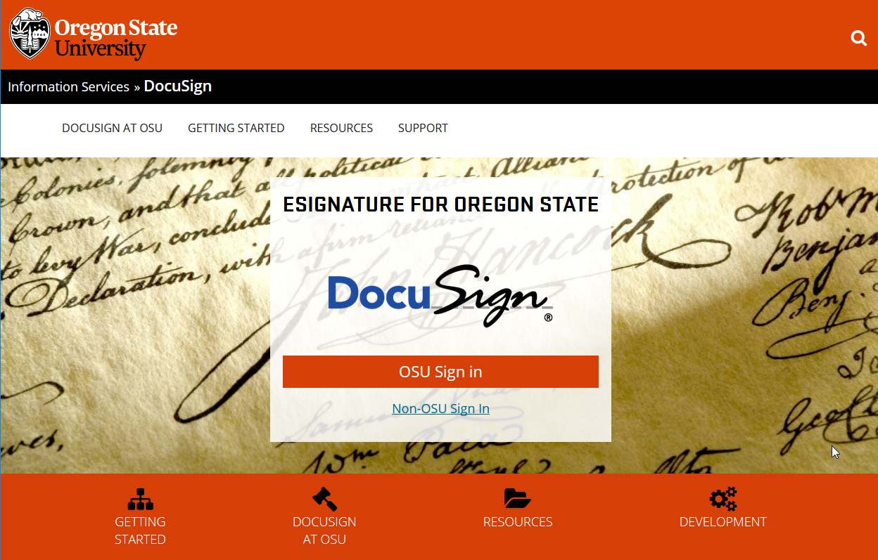

Click the “Sign in to DocuSign” link

Log in using your ONID credentials.

Start the Document

Upon login, the DocuSign Home page is displayed. Here is the top section of the page:

Click the “New” button,

then choose “Send an Envelope”:
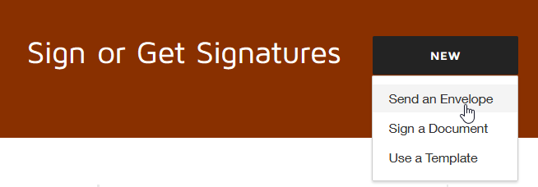

The system will display the “Upload a Document and Add Envelope Recipients” dashboard:

Under “Add Documents to the Envelope”, choose “Upload”:

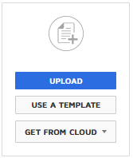

Your browser’s “File Upload” screen will be displayed:

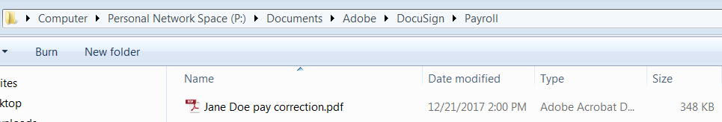

Browse to your document. Click on it to select it. Then, choose “Open”

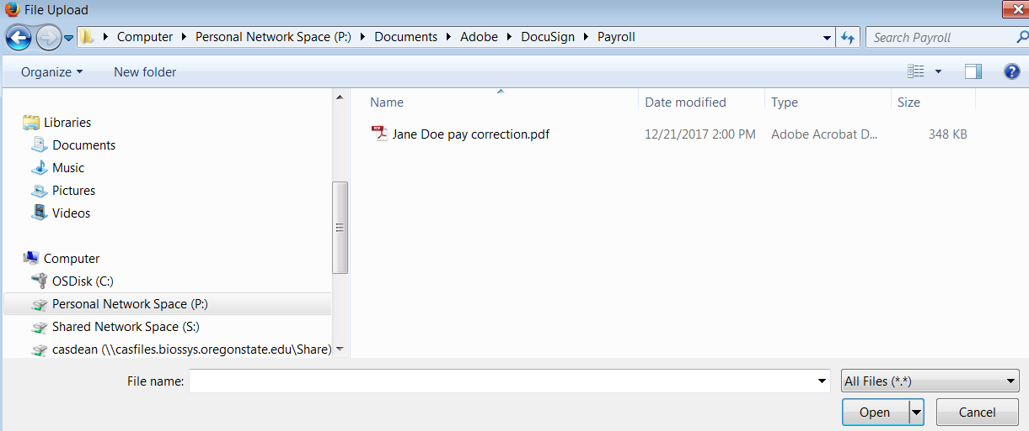

DocuSign will upload the document you have selected.

Additional Supporting Documents
Additional, supporting documents may be uploaded by using the “Document Upload” icon:

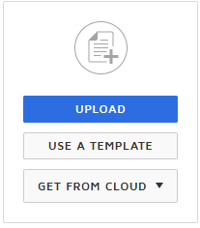

which is shown adjacent to the icon of your initial form. You may add several items, as a new button will open after each addition. These additions are appended to the form to create one document.

Add Recipients

In this case, assume you as preparer need to sign the form. It is then routed to the approver for electronic signature. After the approver signs it, OSU Paymaster will receive a copy for processing.

Using the ADD RECIPIENT button, enter your name as the first signer, the approver as the second signer and the OSU Paymaster as the third recipient (OSU Paymaster is a signing group that can be accessed by multiple personnel in the Payroll Office). For OSU Paymaster, click on the Needs to Sign and change it to Receives a Copy:

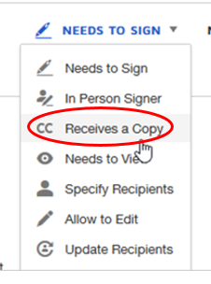
Assume in this case that Jack Breen is the preparer and Hollie Pitts is the approver:
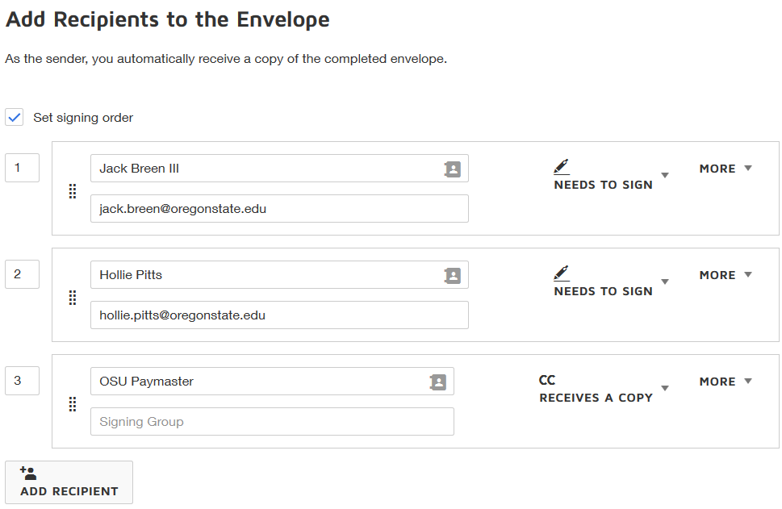

If you would like to add more recipients in order to send someone else a copy, use the ADD RECIPIENT button,

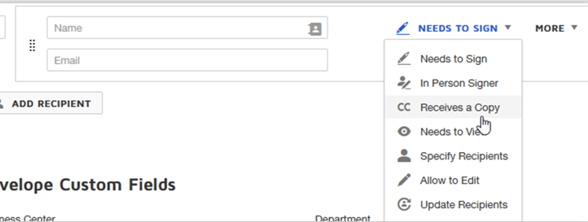
and specify their role as “Receives a Copy” instead of “Needs to Sign.”

Now, check the document itself

Press “Next” in the upper right corner of the screen:

The system will display the form you have uploaded:

The signature and tags now need to be added to the signature lines. Jack Breen is the first signer, it will appear as follows:

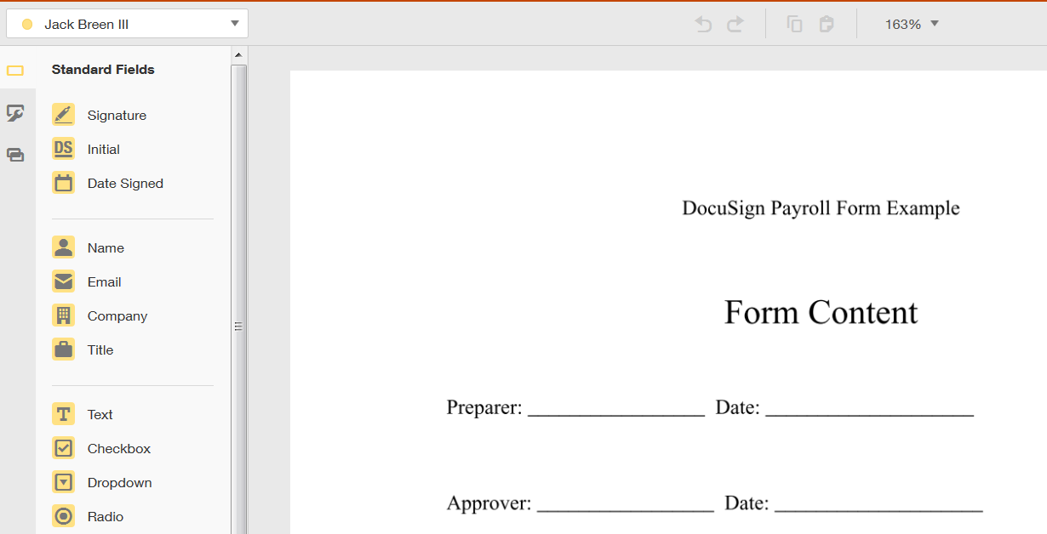

Drag and drop a signature tag for each signer (in this example, the form also includes the date). The number of recipients and nature of the tags will vary depending on the form:

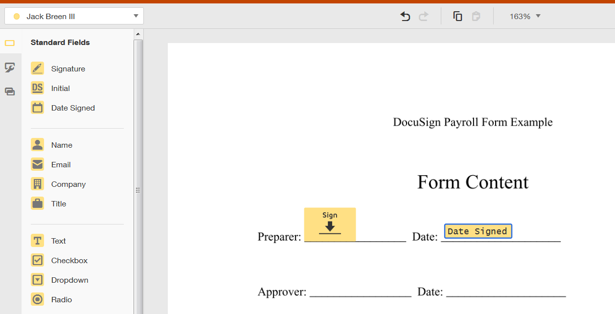

Use the arrow on the upper left to add tags for the additional signers and so on until you have added all the signers. :

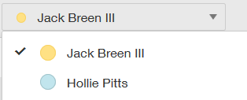

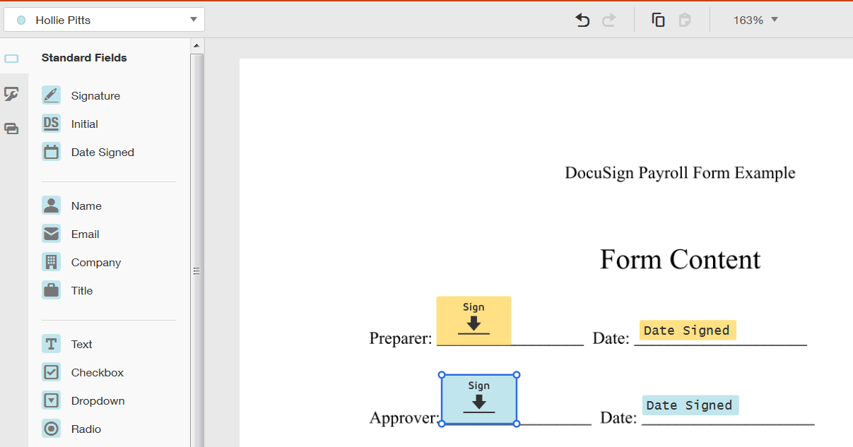

While you should not need to make adjustments, you may make any necessary adjustments to the positions of the tags either, individually (select the tag by clicking on it) or as a group by using your mouse to drag a box around them. You may also move selected tags with your keyboard arrow keys, or the alignment keys at the top of the right panel:

Send your Document

When you are satisfied with the placement of the tags, press “Send” in the upper right corner of the screen (it will initially be sent to you and you will be asked to sign it):

Monitor the Status of your Documents

On the DocuSign home page, you will see an OVERVIEW panel showing the status of your documents, grouped by “Action Required”, “Waiting for Others”, “Expiring Soon” and “Completed”. Click on the area of interest to review documents.

