Draw Request Procedures:
There are two forms associated with draws; the Request for the Emergency Draw and the Payroll Disbursement Request form. Both of which can be found on the OSCAR website http://oscar.oregonstate.edu.
The appropriate information and signatures are required for the draw to be approved and processed.
Draws may only be taken on employees earnings to date in the current pay period, not on their projected month’s earnings. Graduate students, academics, unclassified and classified employees are limited to a draw of 60% of those earnings while hourly temporary employees and undergrad student employees are limited to 75% of those earnings.
The Process – in short:
- The employee completes their draw request section per the instructions below.
- They bring it to a supervisor to be completed and signed in the “to be completed by employee’s supervisor” section. The supervisor should be sure to mark the Yes or No boxes answering regarding fiscal responsibility.
- The business center payroll staff complete the department section according to the directions below, verifying the employees position and wages earned to date. The BC payroll staff will print and complete the Payroll disbursement request form according to the directions below.
- The employee or BC Payroll staff submit the forms to central payroll for processing. They can mailed/hand delivered to the Kerr Admin building central payroll office.
- The draw is available at noon or after the following working day after the central payroll office receives the forms unless the employee is notified otherwise that the draw is denied or there is a problem.
How to complete the forms:
Emergency Draw form:
Section 1 – Employee: The employee requesting the draw should complete the top portion of the draw form with their name and ID and the amount of the draw they are requesting as well as a brief description of the reason for the draw. An emergency situation is defined as an “unusual and unforeseen event or condition that requires immediate financial attention by an employee.” Such circumstances include a death in the family, major unexpected car repair, theft, accident or sickness, destruction or damage to home, or a new employee who has not yet received pay from the university.
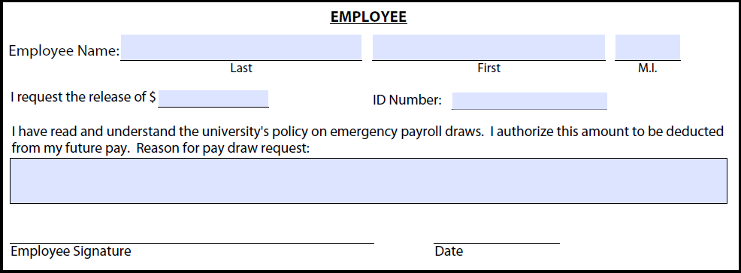
Section 2 – Department: This is the section the business center payroll staff must complete for the employee. This section must be completed by someone other than the employee or the signing supervisor. Three different signatures are required on the draw request form. The staff person completing this section should verify the employee’s position number on which they will receive the draw, the earnings to date on that position and that the amount being requested is no more than the 60 or 75% of the total pay, the allowed per the employee type. If the employee is hourly a timesheet would be required to determine the hours worked and thus the appropriate earnings to date. If the employee is salary the earnings can be determined by the number of working days worked in the month and the pay amount for that employee.
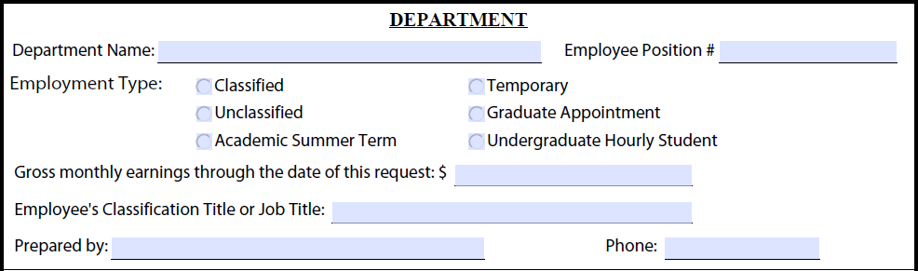
Section 2b – “To be completed by employee’s supervisor”: This box must be completed by someone other than the employee or the person who completed the previous department information. It should be a direct or acting supervisor or manager to that employee or someone above that supervisor or manager. They must mark the Yes or No boxes regarding the fiscal duties and sign and print their name as requested.
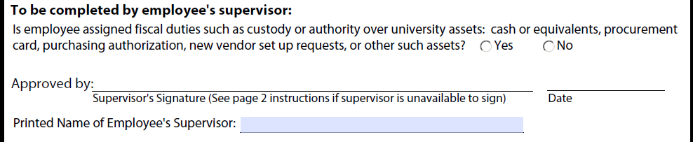
Payroll Disbursement form:
The business center payroll staff who is completing section 2 on the draw request form should print or complete this secondary form. Fill in the name and identifying information of the employee. The “Requested By” box can either be the name of the personnel completing the form or the employee themselves.
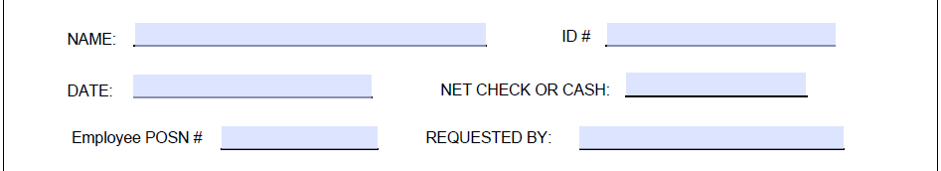
A draw will generally always be drawing on the current month so putting that pay month in the “Current Month Payroll Draw For _____________” line will complete the middle section. Occasionally an employee may draw funds on past pay due and the “Late Pay Draw For ___________” line would be completed, but generally if pay is actually already due to the employee the payroll office would simply request and create a manual check to pay the employee the due wages rather than draw funds on that pay.
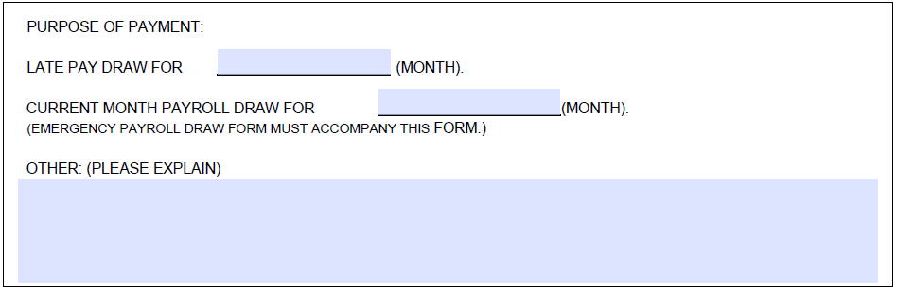
The same person may fill in their name on the “Prepared By” box and then may sign as the Departmental Approval box. This must be someone other than the employee themselves and should be the BC payroll staff who is completing the form.
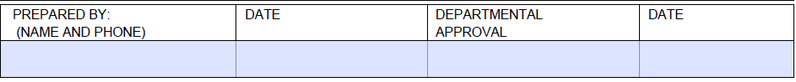
Final Step:
Central payroll will verify the number of draws the employee has received. An employee may receive no more than three draws within a rolling year (from the first request – not calendar year). Should the employee need more draws than this it is at the discretion of the Central Payroll office and they may require more information regarding the draws purpose to approve it.
The draw will be picked up by the employee at the payroll window in the Kerr Administration building at noon or after the following business day after they have received it.

Repayment:
Central payroll will process the draw through the system and will be responsible for the collection of the draw funds from the employee’s next paycheck. The draw does not replace the employee’s regular paycheck and time will still need to be reported and entered into the time entry system. The employee and the department do not need to notate the draw on the timesheets or reduce hours or pay in the time entry system to compensate for that amount. The draw amount will be identified on the earnings statement or pay stub as a “draw recovery.”
Draws requested too late in the month for Repayment in the Banner system:
If a draw request is made after payroll processes have advanced beyond deduction entry time, a personal, post-dated check will be required from the employee as repayment for the draw. The personal check will be held in the central payroll office until Payday when the employee receives their full paycheck and then deposited for collection.

