Benchmarking Other Institutions: Elements of Best Practices

One of the goals for the OSU Carbon Action Plan is to engage the various departments, academic units, and schools on campus to develop their own greenhouse gas reduction action plans. Successful engagement necessitates some guidelines in order to provide both support and recommendations. Yale and Emory University are examples of institutions that encourage each school to develop individualized plans to reduce GHG emissions.
At Yale University the view is, “Our success depends upon leadership and engagement at the individual, departmental, and institutional levels. We have a responsibility to future generations to ensure that sustainable practices are at the heart of our university” (http://sustainability.yale.edu/sites/default/files/files/sustainabilitystrategicplan2013-16_20131029.pdf). Yale University started a program to have the Office of Sustainability collaborate “with each of Yale’s professional schools to develop a set of Sustainability Action Plans that are tailored to the disciplines and physical contexts of the schools” (http://sustainability.yale.edu/planning-progress/president). The result is division, school, and cultural-space plans (http://sustainability.yale.edu/planning-progress/department-level-plans).
Emory University is noted for allowing each college to prepare its own climate action plan within the guidance from the University climate actions plan (http://sustainability.emory.edu/page/1014/Climate-Action). Emory is also notable for the brevity of its University (27 p.) and college plans (under 10 p.).
Both Portland State University and Cornell University provide tactical and strategic guidance to encourage carbon emission reduction. At Portland State University (PSU), they created the “PSU Climate Champions Guidance Document”, a 10-page guideline about how each department can address both GHG emissions and other sustainable behaviors through energy conservation, transportation, water conservation, purchasing and waste prevention, and recycling and composting (http://www.pdx.edu/sites/www.pdx.edu.campus-planning/files/ChampionsChecklist_form.pdf ).
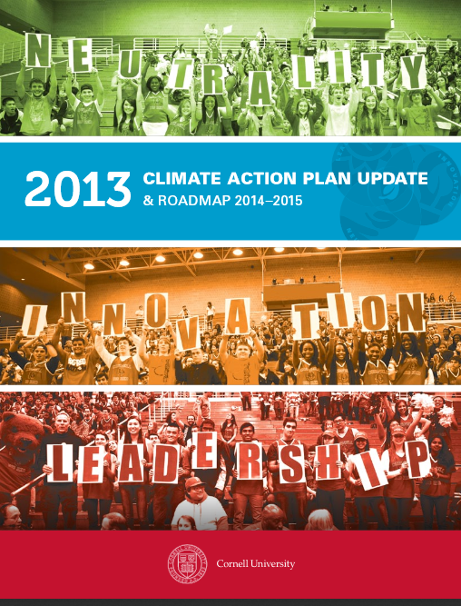
One of the best planning documents and effective implementation of greenhouse gas reduction actions is Cornell University. Cornell makes sustainability and climate action significant pieces of their university culture. From the beginning, Cornell has had extensive funding for developing plans and implementing actions. Cornell seeks to be a leader and prides itself on its leadership both within and outside the University. The priority of actions to avoid, reduce, replace, and offset puts emphasis on real change. The easiest way to climate neutrality is purchasing offsets, yet offsets allow continuing current practices with a self-imposed tax. Offsets do not change the underlying factors that lead to greenhouse gas emissions. Cornell’s projects are designed to reduce greenhouse gases, be cost efficient, and show social responsibility. Cornell’s approach in keeping with their culture is comprehensive, “While greenhouse gas reduction has been a critical focus from the inception of the CAP, this update recognizes the importance of Cornell's education, research, and public engagement activities—which are at the core of everything we do.”
Cornell University created an Excel spreadsheet form covering actions related to energy, climate, water, food, waste, buildings, people, land, purchasing, and transportation. The excel spreadsheet outlines actions to be taken, a checklist for achieved actions, and a point system that provides a ranking for certification (four levels of certification are available). The Cornell program provides both guidance, and the ability to report your level of achieved outcomes for GHG reduction and sustainability. The excel spreadsheet can be found here: http://www.sustainablecampus.cornell.edu/initiatives/green-your-office. PSU and Cornell documents have been the basis for the OSU Climate Action Plan Tool (CAPT, Appendix B)

Outcomes: Energy Efficiency, University Benefits
Many universities have some list of recommendations on how to reduce things like energy use, transportation alternatives, water savings, and effective goods purchases. Some schools, like UC Berkeley offer financial incentives for department/building energy reduction. Berkeley’s Energy Management Initiative has resulted in over $2 million in savings. And, various administrative and academic units have received over $870,000 for energy reductions. More information is available at http://sustainability.berkeley.edu/mypower
Also, unique about Berkeley is the attention paid to embodied emissions (Berkeley uses “embedded’). These are all the emissions created over the entire lifecycle of an item. The amount of energy used by computer is known and can be reduced with Energy Star™ design. Yet the creation of materials for the computer, its assembly, shipping, and disposal also add to its climate impact.
The successful peers have been most effective in dealing with reductions in the share of purchased energy and installing cogeneration with a more climate neutral footprint. A summary of our study of peers is below.
- Schools that have the best synthesis “across the board” have interdisciplinary programs in place that create synergies within and without individual institutions. Examples (Tri-College Fellowship outside Philadelphia (which includes Haverford, Bryn Mawr, and Swarthmore Colleges), Cornell’s Atkinson Center for a Sustainable Future, or Green Mountain College’s required sustainability project) all display ways to create and support a culture of sustainability. Ultimately it is important that institutions create sustainability minded citizens that have tools they can use to alter policy in the world at large.
- It is important for institutions to use a smart and visually appealing mix of data for their climate action documents. While this might seem like a small detail, and overall not that important, the “look and feel” of any document precludes its efficacy. Cornell’s CAP is bright, graphically oriented, and visually stimulating; it also displays interdisciplinary skill sets with ease, and is the product of multiple college’s students and faculty. Other examples like Cornell’s CAP can also cross over into municipality, county, or state responses to climate action and reinforce the roles that colleges and universities could have as concept leaders.
- Many of the AASHE score standouts have reduced their purchased power emissions and have shifted to on-campus generation of heat and electricity. While there are broad, possibly entrenched cultural reasons behind how some of these schools were able to achieve this, the shift from purchased to locally generated allows for greater control of types of generation, decreases in transmission loss, and the ability to shift off of dirty technology like coal. A local production focus allows cultural preferences at the university level to take precedence over potentially conflicting attitudes at the state level; it also allows for possible innovation at the institutional level.
- Oregon State needs to reach out to community and industry partners to achieve our climate action goals, as well as potentially help influence environmental, social, and economic policies where possible. The University does not operate in a vacuum. It can be difficult for communities to vest themselves in a vision they neither helped create, nor understand.
Land grant extension services may be a valuable tool for sustainability education at the county level, but not if they get defunded! There is capacity for sustainability education and outreach through extension programs, but it does not appear that any such systems are in place.

