Financial Budget Reports – CORE Report FIN1863

Instructions:
- USE Chrome or Firefox
- Go to Core.oregonstate.edu
- Log into the site using ONID login and password

Core Homepage
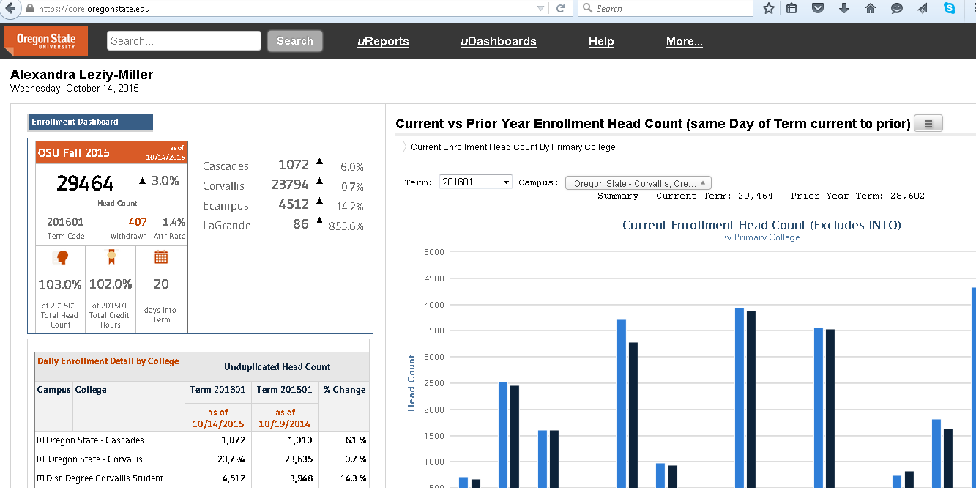

Accessing the Report
- Select uReports on the toolbar:
- Select Finance Data Area
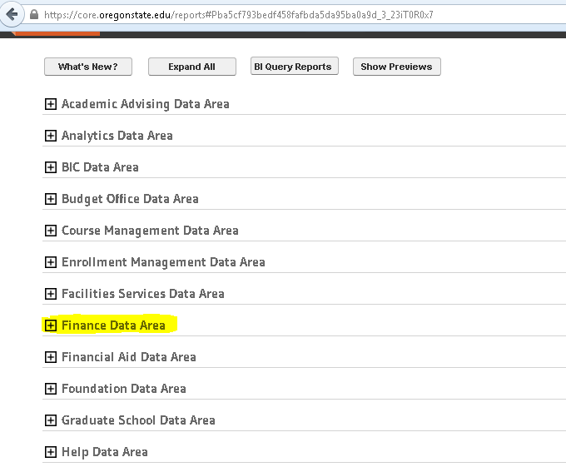
- Select Operating Ledger
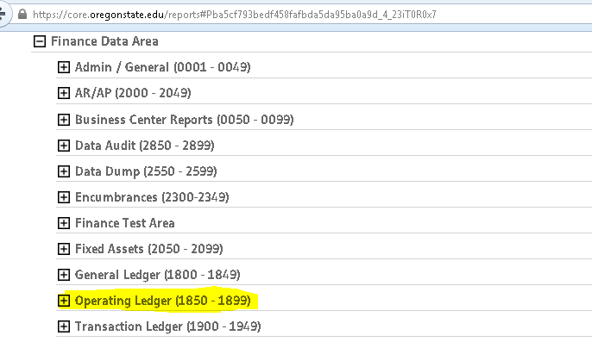

- Select FIN1863 Operating Statement – Year over Year variance by Index
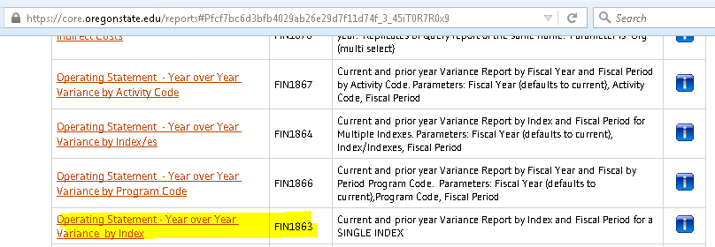
- Enter the report criteria.
  - 1) Input Index, 2) fiscal year, 3) report rollup definition (select SIFC), 4) period, 5) history (2 or 3 years of history available), 6) service credits (select reclass as income), 7) transfers and depreciation (select reclass below the line).
    - Please note the default for Period is the last closed period. You have the option of selecting the current open period to display as well. July = 01.
    - The report will generate with the current fiscal year on the top section and prior fiscal years below.
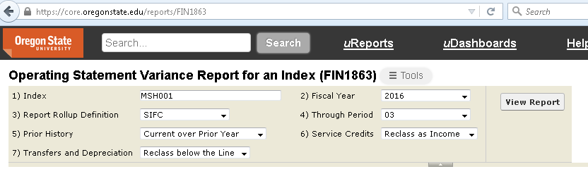
- Once you have entered the report criteria, select view report.
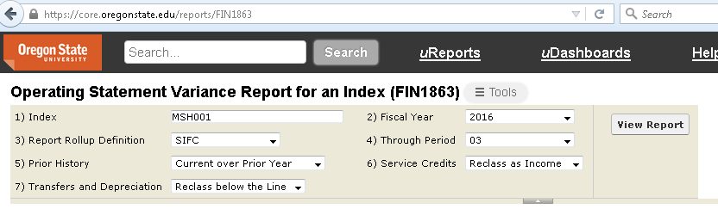

Reading the Report

Terms:
- Fiscal Year: Timeframe July 1st – June 30th
- Acct Level: Revenues are account level 1; expenses are account level 2; transfers and depreciation are account level 3
- Account Category: contains account code categories; drilldown available (see page #6 for instructions)
- Month: Contains months July through June
- Accrual: Income or expenses can be accrued at fiscal year-end. These are receipts for services rendered, but income not received by June 30 or payments made in advance for goods or services not received by June 30
- YTD: Year-to-date
- Budget: Budget amount approved through Student Incidental Fees Committee (SIFC)
- Variance: Difference between YTD to budgeted amount
- Actuals to Budget: actual YTD income or expense activity to planned budget shown as a percentage
The top section of the report from left to right: Columns contain the Fiscal Year, Acct level, Account Category, Months, Accrual, YTD, Budget, Variance and Actuals to Budget.
Calculations Defined:
Variance = YTD – Budget
Actuals to Budget = YTD/Budget

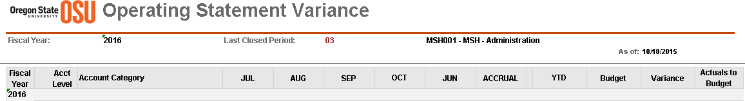

The left hand section of the report from top to bottom: Contains account category information by Revenue, Expense, Transfers and Depreciation sections 1, 2 and 3, respectively. Income earned and Expenditure Burn Rates are also tabulated as a percentage by month against the budget. For example, in July of Fiscal year 2016 the represented index had earned 9.00% of its total revenue budget of $1,125,040.
Calculations Defined:
Income Earned Rate = Total Revenue by Month/Budget
Accumulative Earn Rate = Total Revenue month x + Total Revenue month y/Budget
ex. July Total Revenue + August Total Revenue/Budget
Expense Burn Rate = Total Expense by Month/Budget
Accumulative Burn Rate = Total Expense month x + Total Expense month y/Budget
201x Net Total = Total Revenue – Total Expense – Total Transfer and Depreciation

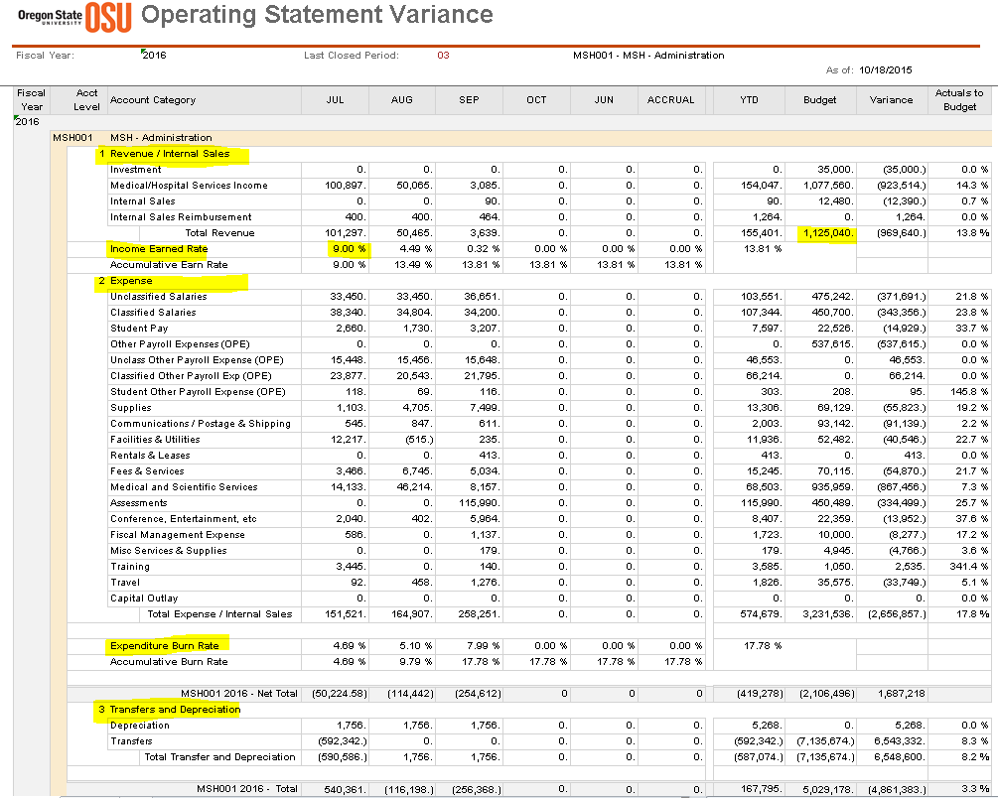

Each Account Category contains a + sign indicating a drilldown option is available.
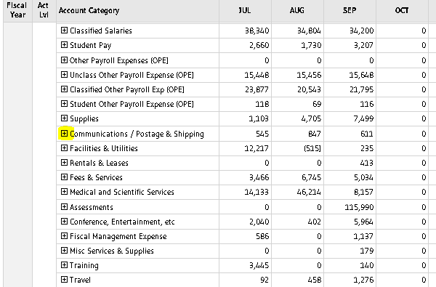
Click on the + sign to expand the category. Here you will find an expansion of the account category line to account codes. You can also click on any of the numbers in the report to drilldown to further detail.
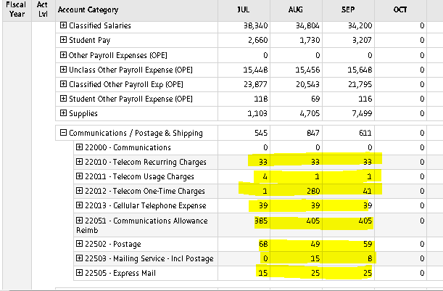

Click on the number and further detail on the account appears including the transaction details. The Nolij document, represented by the red N symbol is available for viewing. This is the original documentation that has been scanned. Examples of Nolij documentation can include the invoice, supporting documentation such as PR’s, agenda’s, advertising announcements and budget authority approval.
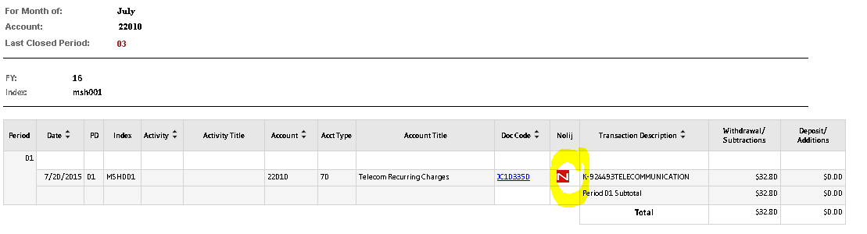

Printing Reports
- There are multiple formats to print the report. Select the tools dropdown in the top header section.
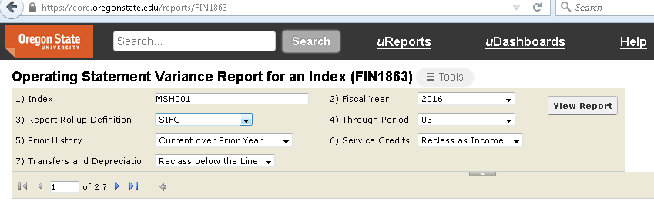
- Select the format for which you would like to view the report.
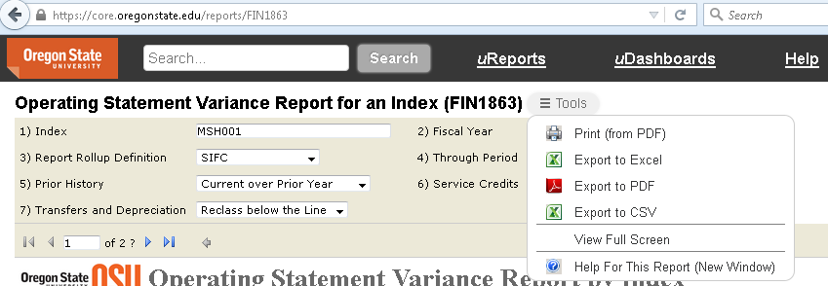

Other helpful CORE Tips
- Help section: Select the help option on the toolbar for a directory of help resources.
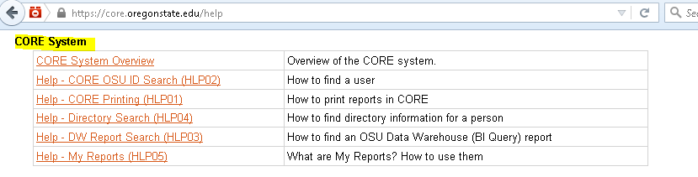
- Recently accessed reports: when logged into CORE a quick list of your most recently viewed reports will show at the bottom of the screen. Click on any report for quick access.
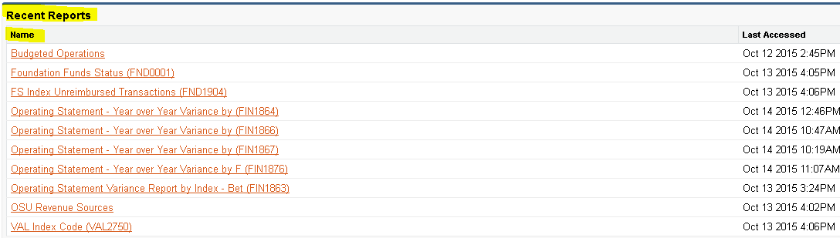
- The search bar: this is a useful tool for searching for a report. For example: enter FIN1864 to go directly the link for a particular report.

