Clearing 40199 Balances for Capital Assets

What is a capital asset?
- Free standing single unit
- Used to conduct university business
- Not consumable and not intended for sale
- Has a useful life of one or more years
- Has a unit value of $5,000.00 or more
Attachment:
- An attachment is defined as a piece of equipment that is integral to the parent asset.
- It must be purchased and capitalized in the same fiscal year as the parent asset.
- The $5,000 threshold does not apply to the attachment.
Upgrade:
- Major reconditioning of capital equipment that extends the useful life of the equipment by more than two years.
- The Cost of the upgrade to an existing asset should not be added to the existing equipment and should not be capitalized as a separate piece of equipment. An exception is granted if the upgrade is done at the time of purchase and during the same fiscal year (FY) as when the asset is originally setup.
- Use account code 23505 for the cost of an upgrade.

What to include in the cost of capital equipment?
Everything paid to receive and place the equipment into service such as:
- Installation, freight charges, import cost (custom, brokerage, and tax) and in-transit insurance
- Vehicle registration and license fees
- Software is included only if it is embedded in the cost of equipment
- Parts that are permanently attached to the equipment
- Modification costs during purchase or after in the same fiscal year.
What to exclude from the cost of capital equipment?
- Warranty/maintenance contract/protection plan, if they are separate line items on the vendor invoice
- Software, if it is a separate line item on the invoice
- Subscription or software license user fees, when billed as a separate line item on the invoice
- Cost of training, when it is a separate line item on the invoice and not embedded in the cost of equipment
- Consumable accessories (batteries, cartridges, etc.)

See https://fa.oregonstate.edu/pro-manual/200-equipment-acquisition for more information regarding equipment acquisition.

Asset Capitalization
There are multiple ways to capitalize an asset.
Asset Capitalization from an Invoice:
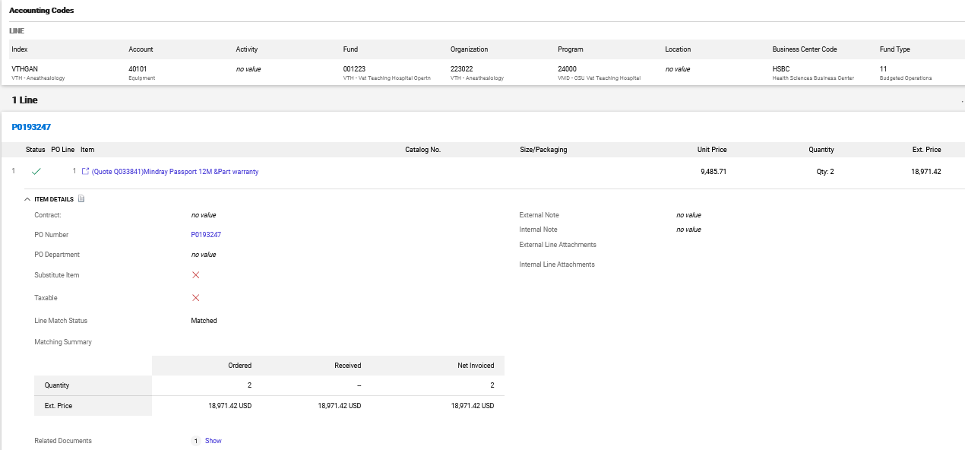
Purchase Order (PO): When an on-line purchase order is issued using the 40101 or 40104 account code (click the link 202: Purchases) there should be a separate line item for each capital and non-capital item in the product description of the PO. This ties an accounting distribution to each commodity on the PO. When commodity level accounting is used, the accounting information and commodity value information feed into the invoice and the Fixed Asset system. It is very important to pay attention when setting up product description lines when using account code 40101 and 40104 to make sure the product description line item meets the fixed asset criteria above. Auxiliary and Service Centers should never use 40101/40104 account codes and always use 40199 when setting up a purchase order.
Processing an invoice with capital account code (40101 or 40104): When payment is processed against a Purchase Order, the invoice defaults to the Product Description level of the PO. The data from each product line automatically feeds into the Fixed Asset module, creating a temporary origination Tag (T0xxxxxxx) for each product line item using 40101 or 40104. Therefore, it is very important to pay attention when setting up a product description line in a PO. Only one Asset Tag should be created for each product description line that meets the fixed asset definition. For PO invoices, the accounting codes on the invoices must match what is listed on the PO. They cannot be changed in BennyBuy.
Tip: If a change is needed to an account code there are two options:
- Process a PO revision to change commodity lines to the PO and attribute the new accounting to those lines. Once the revision is finalized, the PO invoice can then be created against those new lines. For more instructions on this, see: Processing PO Revision.
Note: PO Revisions are only eligible on orders where the Purchase Request form was used.
- Cancel the PO invoice and process the invoice as non-PO invoice with correct account code or commodity line. Liquidate the PO manually.
When account code 40101 or 40104 is used, asset information (click the link for FADE Form) is required before the invoice can be approved by Fixed Assets. See instructions for filling out the FADE form on page 4.
To expedite the approval process, forward the FADE form to the PI/Shopper when processing the PO for the capital equipment. Fill out as much information as possible to make it easier for the shopper to fill in the rest. For example, fill in the organization code, how acquired (purchased with state funds, federal funds or purchased with other funds), title-to, and department name.
The following PO and invoice are processed correctly. The product description line in the PO is one line which creates one tag and the cost distribution to various index codes are done in the accounting level. 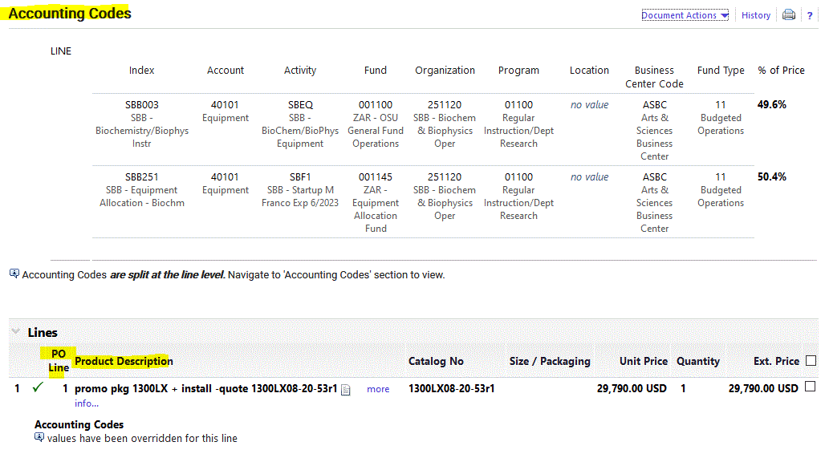
The PO and invoice below are not correct. The distribution to various account codes should be done in the PO line (commodity level) and not in the accounting section.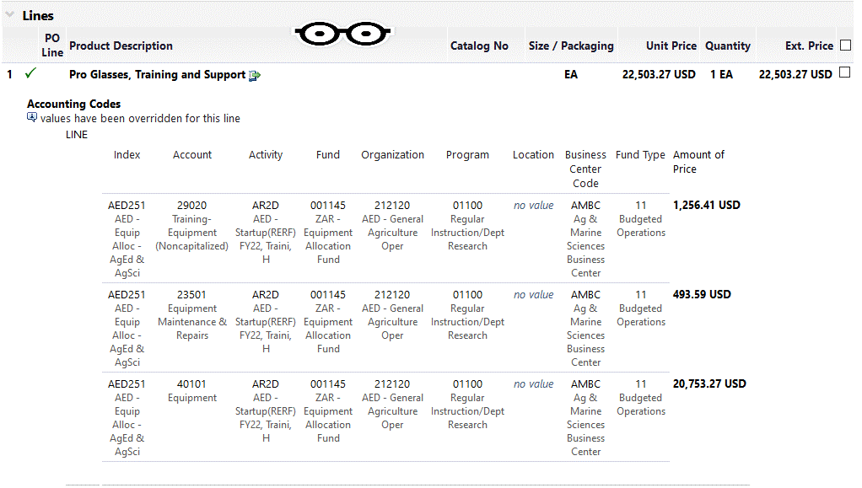

Asset capitalization from Journal Voucher (JV):

Using account 40199:
In situations where account codes 40101 or 40104 cannot be used because asset is not complete or there are multiple invoices for the equipment or the purchase is for an auxiliary or service center, use 40199 for capital equipment purchases. Account code 40199 is not linked to the Banner Fixed Asset Module and does not create an Originating Tag (T0xxxxxxx) in the Fixed Asset system when the invoice is processed for payment in BennyBuy or Banner.
Note: Account code 40199 is a temporary account code, and the expense must be moved off to 40101, 40104 or other appropriate account code
40199 clearing policy:
Any invoice that is posted to 40199 must be moved off to the appropriate account code via a journal voucher (JV) as early as possible or at least once each quarter. This is intended to give the Fixed Asset office enough time to setup each capital asset record and tag the equipment in a timely manner (see Clearing 40199 Entries for more details).
Tip: Before using account code 40199, look at the capital equipment criteria to verify the intended transaction meets the capitalization criteria. If it does not meet the capitalization criteria, move the invoice to an appropriate account code such as 20200 Minor Equipment, etc.
Do not wait until the end of the fiscal year to clear 40199 expenses. Please clear these expenses as soon as possible to allow for enough time to focus on other end-of-year projects.

FADE form fields:
- Description: The asset description, beginning with a generic noun: (i.e., Computer Server, Truck, Microscope etc.)
- Department: Department title (i.e., Engineering/Athletics)
- Org Code: The Responsible Organization code (i.e., 303000, 261100, 409000 etc.)
- Status: Choose from drop down list (Received/Work in Progress)
- Received date: When the equipment was received, or fabrication start date on the campus
- In use date: When the equipment is installed/delivered to department. Often the same as the receive date.
- Location: Building name and Room number if on campus (i.e., “Burt Hall Room 112” or Extension County)
- Value: The amount for 401xxx on the invoice/JV (total adjusted cost, if completing the asset)
- Condition: Choose from drop down list
- Manufacturer: Enter the Manufacturer name (may be different than the vendor)
- Model number: Enter the model number
- Serial number: Enter the serial number
- PI/Custodian: Responsible person
- PI/Custodian ID: OSU ID Number
- Use Code: Choose from drop down list
- Title To: for most cases use “SI” if complete or “SN” if work in progress. “FI/FN” if the Grant condition states that equipment will be owned by Federal Granting Agency, not OSU.
- How Acquired: State funds (PS) Federal funds (PF) Foundation and other Funds (PU) & mixed funding (PU)

Frequently Asked Questions
Question: Do I need to clear 40199 even if the asset is not complete by the end of quarter?
Answer: Yes. Even if the asset is under construction and not yet complete, a JV must be processed to move 40199 to appropriate account code. Select “Work in Progress” in the status box of the FADE form and process a JV as you would for any capital equipment.
Note: Not all information may be available such as In Use Date, Model, Serial Number or Location.
Leave the fields blank on the FADE form if the information is not available when processing the JV.

Question: What backup document must be included with the JV?
Answer: FADE form and a copy of the invoice (if available).

Question: Do I need to add a FADE form every time I process a JV when moving 40199 to 40101 or 40104?
Answer: No, a FADE form is only needed for the first JV processed to set up an asset in the system. Any subsequent JVs that add additional costs to a work-in-progress (WIP) asset, only need to have the asset tag number (Ptag) in FOATEXT . If you don’t know the asset tag number, list the initial JV number from which the asset record was set up in the system.
Contact Fixed Assets for a listing of equipment that is under construction (WIP) for your Org/Business Center (BC).

Question: What if I don’t have all the information to fill out the FADE form?
Answer: All asset information is required to properly set up the asset record in the fixed asset system; however, if some information such as the Serial Number, Model, etc. are not available, then process a JV to move off expenses from 40199 as listed above and add a note in FOATEXT that this information will be provided when available.

Question: Do I need to process a separate JV for each invoice?
Answer: No, every time we add additional costs to an existing asset, it requires several steps to update all records for that asset, so all invoices should be processed in one JV for the same asset with multiple lines referencing each IB OR IDOC#.

Below are JV examples that are clearing 40199 and adding value to the cost of a WIP asset:
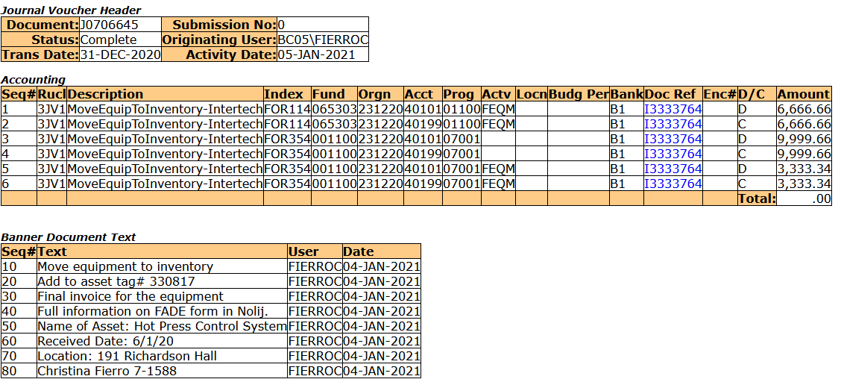

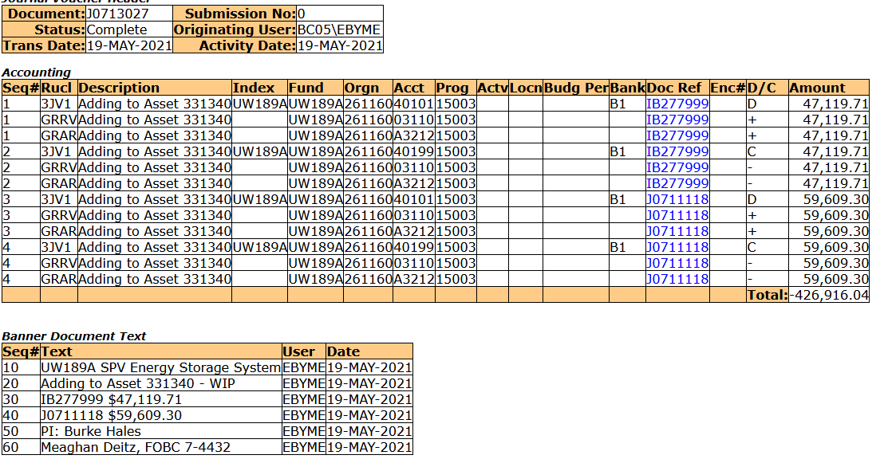

Prepaid Invoices

If a vendor requires a prepayment before shipping the equipment, the invoice can be processed using 40199 but the expenses must be moved off from 40199 by a JV to A5008 Prepaid Equipment Expenses. Once the equipment is received, credit the prepayment account (A5008) and debit the appropriate account code such as 40101, 40104, etc. See example below:
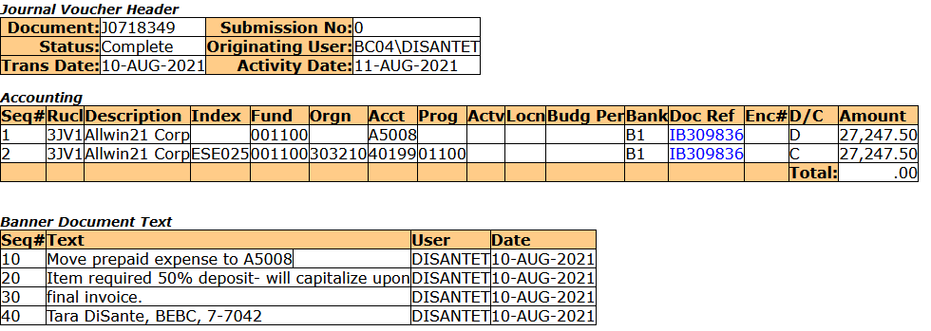

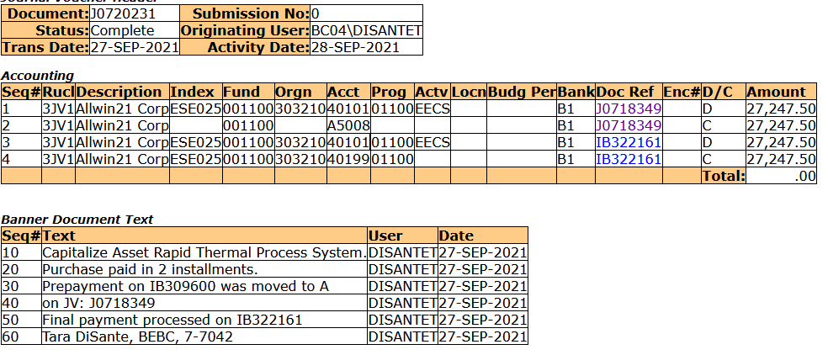
Fiscal Year-End (FYE) Tips
Asset paid in current FY but has not been received by the year end:
A JV is needed for assets that are paid but have not been received. Credit the expense and debit the fund against A5008.
Asset was received in current FY, but invoice has not been paid:
Get approval from Charlotte Rooks before creating any transactions. Two JVs are needed to correct this situation:
- A JV is needed to move the invoice paid into the prior Fiscal Year (FY):
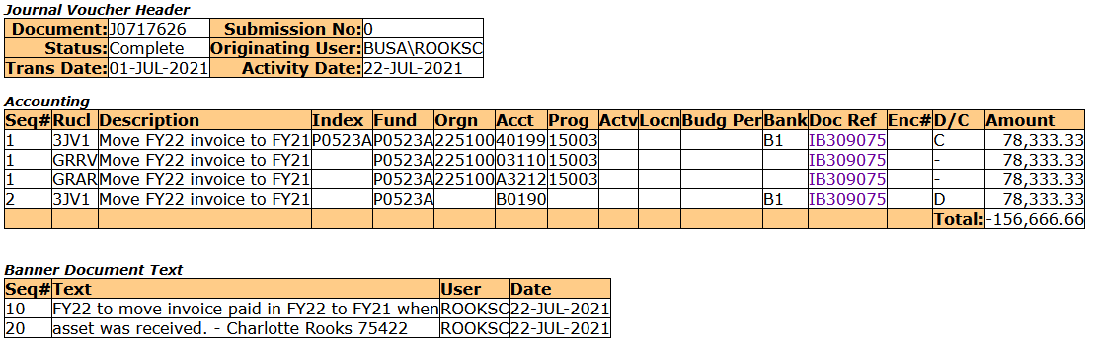

- A JV is needed to set up the asset in the current FY:
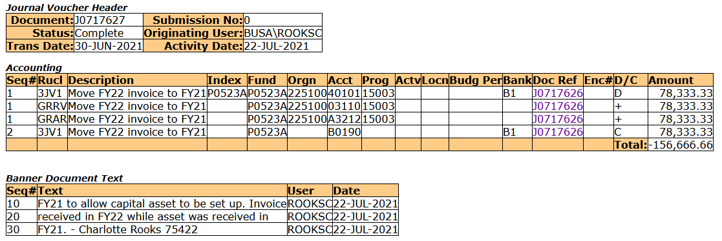

Check 40199 Balances for Org/Index
There are multiple ways to look up 40199 balances for the Org/index that you are responsible for clearing.
- CORE Report: FIN1903
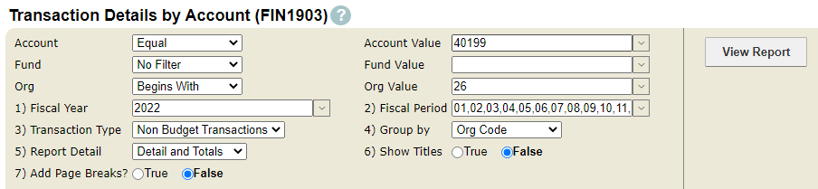
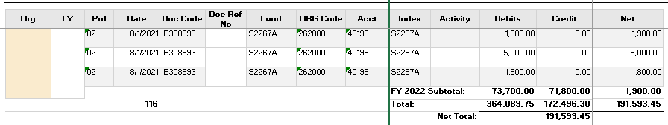

- Banner: FGIBDST

Type account code 40199 in the Account field and enter the index if looking for a specific index or leave blank if looking for multiple indices. Click Go to view report.

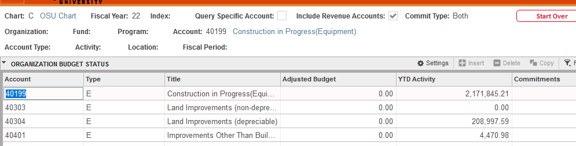

Hit “F3” on account code 40199 to bring all 40199 transactions.

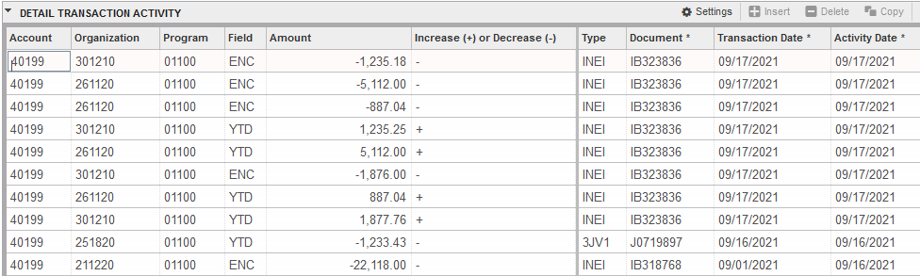

Use the Filter function to choose all transactions with YTD in Field.
Click on “Tools” on the upper right corner to export into Excel. Filter for any organizations where you are responsible for clearing the 40199 balances. Change Commit type to “Uncommitted” to show transaction details.
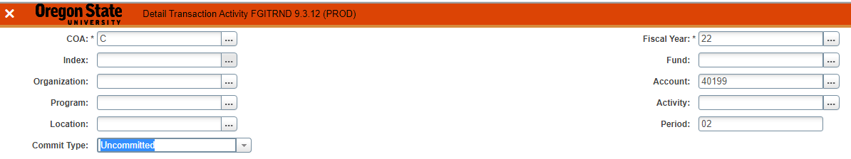
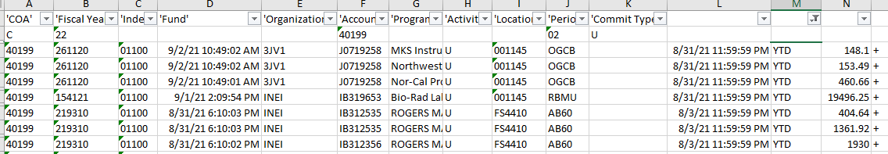

- The Fixed Assets Office sends out a report for the 40199 balances. Use this report to move 40199 balances to the appropriate account code via JV.

Common Expense Account Codes:
20200 | Minor Equipment
20201 | Computer (Non-Capitalized)
20202 | Software (Non-Capitalized)
20203 | Printers (Non-Capitalized)
20204 | Other IT Related Peripherals
20210 | Office Furniture (Non-Capitalized)
20215 | Specialized Equip (Non-Capitalized)
20216 | Sports Equipment (Non-Capitalized)
20220 | Inv Equip/Non-State Funds (Non-Cap)
20221 | Inv Equip/Non-State Funds/RCRV
20225 | Non-Inv Equip/Non-State Funds
20226 | Non-Inventory Equipment/State Title
20250 | Parts-Auto & Equipment
23501 | Equipment Maintenance & Repairs
23502 | Building Maintenance & Repairs
23503 | Grounds Maintenance & Repairs
23504 | IT Equipment Maint/Repair
23505 | Major Reconditioning of Equipment
23506 | Ship/Vessel Maintenance and Repair
23507 | Vehicle Maintenance & Repairs
23510 | Contract Maint/Repair-Equipment
23511 | Contract Maint/Repair-Building
23512 | Contract Maint/Repair-Grounds
23513 | Software Maintenance Contracts/Serv
23514 | IT Hardware Maintenance Contracts

