Oregon State University
NBAJOBS Process Timing and Banner Dates

Central Payroll 737-3232
October 2010

Table of Contents:

Time Entry and How it Relates to NBAJOBS 3
Contacting Central Payroll 4
Effective Date Vs. Personnel Date 5
Effective Date 5
Personnel Date 5
Job Termination Dates 6
Hourly Employees 6
Future Job Termination Date 6
Last Paid Date Termination Date 7
Prior to Last Paid Date Termination Date 7
Default Pay Employees 8
Future Termination Date 8
Run through regular payroll 8
To be paid prior to the pay period ending 8
Prior Month Termination Date 9
Prior to Last Paid Date Termination 10
Using One Effective Date for Multiple Record Changes 11
Multiple Changes on the Same Date 11
Effective Date is Already in Banner 11
Effective Date is Not Already in Banner - Future 12
Effective Date is Not Already in Banner – Retro and Future 13
Effective Date is Not Already in Banner – Retro 14
Making a Comment 15
Job Change on a Terminated Record 15
Record Removing 19
Removing Future Dates that No Longer Apply 19
Points to Remember 20

Time Entry and How it Relates to NBAJOBS:

Time entry occurs mid month every month (see the HR/PR calendar online for exact dates). Time entry records default from the records in NBAJOBS at the time it opens. When PYAHOUR opens, the record will be reflective of the current job record as it is for that pay period. In other words, at the time PYAHOUR opens whatever Job status, FTE, pay rate, etc. are in Banner effective for that pay period (mid month to mid month for hourly, current month for default pay) will automatically load into time entry. Banner will use the Effective Date, or Dates, in NBAJOBS to determine what pay reflects in PYAHOUR. It prorates the records including default hours for any changes that occur within that pay period.
When there is an Effective Date in NBAJOBS mid pay period, Banner will recognize that record change and automatically reflect it in time entry. For example, if a rate of pay change were entered into Banner with a mid month effective date, Banner will create two records in PYAHOUR. One will be at the old rate of pay and one at the new. If the change is for a default pay employee, Banner will prorate the default hours according to the effective dates of that pay period and show the appropriate number of hours to pay for each rate of pay on that position record.

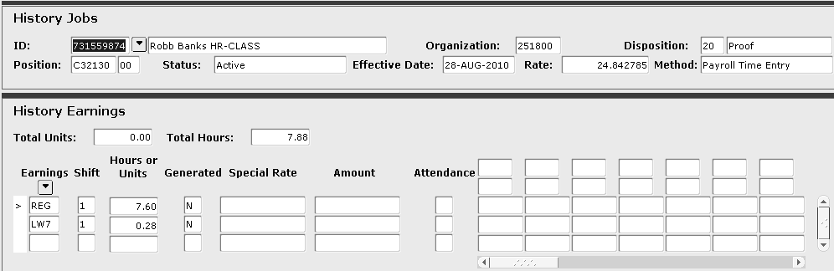
This is the same employee and the same position.
A change was made to the record with an effective date of 09/02/2010

September 1st is being paid on one record while September 2nd through the end of the month is on another.

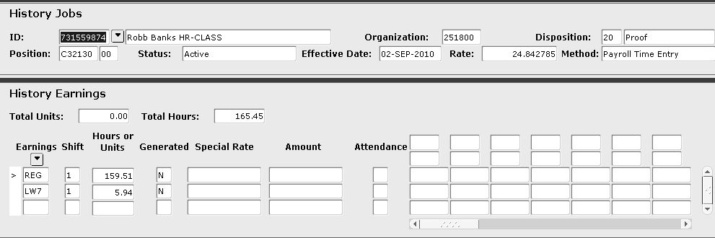
The hours are prorated on each record showing only the hours for that period. The first record is only for the one day, September 1st, the second for the remainder of the month. All together these hours make up 173.33, full time pay.

Once PYAHOUR opens the Last Paid Date in NBAJOBS will show as the last date of that current month and you will no longer be able to make changes to that record for that current pay period; UNLESS you contact Central Payroll (see Contacting Central Payroll).

Consider this timing when you are processing job forms. We “lock out” NBAJOBS during payroll processing so that records are not changed while we are processing that pay period. BUT if you receive a job change or a termination form after time entry has opened that month you may want to process it for that current month. If the change reduces the amount of pay the employee will receive for that pay period CONTACT CENTRAL PAYROLL. Depending on at what point we are in the payroll processing we may still be able to update the record and correct the pay.

Contacting Central Payroll:

When you contact Central Payroll we can advise you on how to proceed based on the job change and timing you are dealing with. Generally, if time entry is still open we will re-extract the record from PYAHOUR so that you can make the updates to NBAJOBS using current month Effective Dates. When the record is reloaded into time entry it will reflect the updates added for that pay period. If it is immediately after PYAHOUR has closed to the Business centers /units, Central Payroll may still be able to make the updates within our office. If contact is made with us after the point where we can update the record this way we may still be able to stop the employee’s direct deposit or pull their paycheck. If this were to occur we would create a manual check to be received on payday with the correct pay amount. Finally if it is too late to do any of these things we will have you complete the overpayment form for collection of the incorrect pay.

If the record change you are processing has no bearing on the current pay period or would increase the pay due (supervisor or timesheet org updates, FTE increases, reappointments) process the change with the following months effective dates once the “lock out” period has past. (See more direction and explanation of dates below).

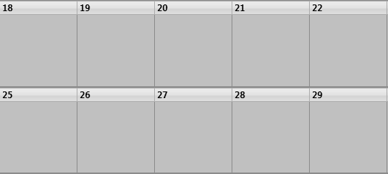
ACH Delete
Stop
Direct Deposit
Final Day
Writs
and
Final Calc
Time Entry Closes
Sample month, deadlines may be different depending on the month.

Effective Date Vs. Personnel Date:

- The Effective Date in Banner is the date the system will begin to default with the information entered for that date (i.e. starting to pay, changing FTE, new pay amount). The date entered is the first date that change can take effect in the system and Banner will use that information until another date in entered to change or stop that record. Banner will pay through this date if the status is Terminated.
- The Personnel Date has no bearing on the database functionality. This date is only for records purposes and is used to reflect the true date the event should have begun. This is only a different date from the Effective Date if the change is prior to the last paid date or retroactive for that employee.

The Personnel Date should NEVER be after the Effective Date.
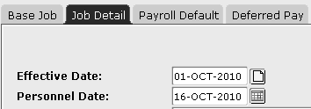
Example:
- An employee’s FTE is changing October 16th 2010. The date you are processing this job change in Banner is in September. Enter a new Effective Date of 10/16/2010 and leave the Personnel Date the same. Banner will automatically use the prior FTE for the first part of October and the new FTE starting 10/16/2010.
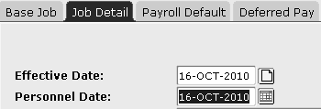

- An employees FTE is changing September 16th 2010. The date you are processing the job change in Banner is in October and the employee has already been paid for September. Enter a new Effective Date of 10/01/2010 so that starting October 1st the change will be in effect. Enter 09/16/2010 as the Personnel Date to reflect that this change should have begun in September. Now calculate the additional pay due for September and send a pay request or spreadsheet to Central Payroll.
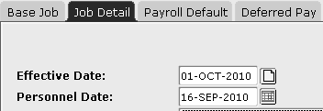

- In both examples be sure to update any future dated JOB records that may already be in the system with the FTE change as well (term dates, future change already processed, etc.).
- On the Job Detail tab you can insert dates between current and future dated records; however the information you add will not automatically update those future dated records. If these updates in future dated records are not made the change will no longer be in effect. If that future date is a termination record, that one day will still default as the prior FTE, or pay rate, etc. and will be incorrect.

Job Termination Dates:

Remember if you are processing a termination form prior to the 16th of the month when the termination takes place you can use the true termination date as the Effective Date and the Personnel Date. If you are processing a termination form on the 17th or after consider when the termination date is and how it will affect the employee’s current pay. You will either contact Central Payroll to adjust their current pay or process the form using the dates as outline below.

Also always consider future dated records when processing a termination. If there is a future dated record and you are terminating the job prior to that date be sure to record remove that future record. If this is not done that date will come into time entry in the pay period it falls in and will begin to pay the employee from that date regardless of the Personnel Date. If the record is a Terminated status record it will only pay that one day but the system will see this as one day to be paid.

Hourly Employees:

Hourly employees are being paid mid-month to mid-month (the 16th of the prior month to the 15th of the current month) but are still being paid monthly on the last working day of the month. If their termination date is after the 16th of the current month they will need to have pay entered in the following month’s payroll.

- Future Job Termination Date:
If the termination date is after the Last Paid Date for that employee’s record you will use the first of the month after their termination date as the new Effective Date. This will cause the employees record to come into time entry and allow for final pay to be processed in the regular system if there are hours to pay.
Example:
    - Employee has active record and will be terminating October 31st 2010. Enter a new Effective Date as 11/01/2010 with a Personnel Date as 10/31/2010. The employee’s record will come into time entry in November allowing work from the 10/16/2010 to 10/31/2010 to be entered in PYAHOUR.

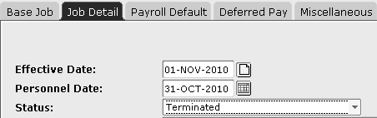
Use this Effective Date for Hourly employees only.

- Last Paid Date Termination Date:
When the termination date is the same date as the Last Paid Date your new Effective Date will be the first of the month after the employee’s termination date. You will do this to bring the record into time entry the following month after their termination date so that the hours the employee worked from the 16th of that month to the termination date can be paid.
Example:
    - Employee has been paid in September and you are processing a job termination effective 09/30/2010. Enter a new Effective Date as 10/01/2010 with a Personnel Date as 09/30/2010. The employee’s record will come into time entry in October allowing work from 9/16/2010 to 9/30/2010 to be entered in PYAHOUR.

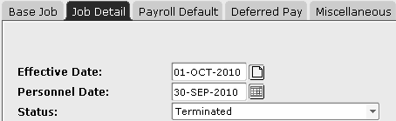
**Do not use this effective date
for salary employees. Hourly Only.

- Prior to Last Paid Date Termination:
If the employee’s termination date is prior to their Last Paid Date you may not need the record to be in time entry again. You will use the Last Paid Date as the new Effective Date and enter the true Effective Dates as the Personnel Date. Termination is the only thing Banner will let you do on the Last Paid Date. Change the status to Terminated and the change reason to TERMJ for a termination of the job or TERME for termination of employment.
    - Example:
Employee has been paid in September and you are processing a termination effective 09/15/2010. Enter a new Effective Date as 09/30/2010 with a Personnel Date as 09/15/2010. As an hourly employee they should not have been overpaid. They should have only been paid for their actual hours worked through the 15th, but you may want to pull timesheets and verify.

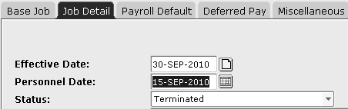

Default Pay Employees:

Default pay employees are paid for current month and leave is reported for the prior month. Even if no action is taken in time entry they will automatically be paid their default hours from the default earnings tab in NBAJOBS. When processing a job change form consider the time of the month and the dates you are using. If the job change is prior to time entry for the month the changes is effective enter the true Effective Date and Banner will automatically reflect those changes in time entry. If you are processing the form after time entry has opened and the change effects the current month consider if the employee will be overpaid if the record is not changed for that pay period and contact Central Payroll to correct the record.

- Future Termination Date:
  - Future termination dates that will run through regular payroll that pay period:
If the termination date is in the future you will want to pay through that date. You will enter the true termination date as both the new Effective Date and Personnel Date. Banner will automatically calculate the correct hours and pay due through that date in that month’s time entry. You do not put an end date on the default earnings tab. Remove any future dated records.
    - Example:
Employee will be terminating on November 22nd 2010. Enter a new Effective Date as 11/22/2010 and the Personnel Date left the same. The system will pay the employee in November for the hours from 11/01/2010 to 11/22/2010 only and no record will be created in December.
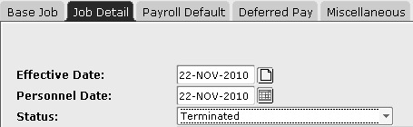

  - Employee Termination date to be paid prior to the pay period ending:
If the termination date is in the current pay period you will want to pay through that date but you may need to pay the employee prior to payday. For example if the termination date is early in the month the employee should not wait to be paid on the last day of that month. You will still enter the true termination date as both the new Effective Date and Personnel Date in Banner to reflect the time the employee should be paid for. Enter an “End as of Date” on the Default Earnings tab in NBAJOBS. Enter this date as the first of the month the employee is terminating. Banner reads this record as from that date no default hours should come into time entry. This prevents the employee from being paid in the regular payroll system as they will be paid by a manual check. Process the final hours and any leave payout due on a termination pay request and send that to Central Payroll. Remove any future date records in NBAJOBS.
    - Example:
Employee will be terminating on November 22nd 2010. Enter a new Effective Date as 11/22/2010 and the Personnel Date left the same. On the most current record in the Default Earnings tab enter 11/01/2010 as the end as of date. Remove any future date records. Create a termination pay request form with the hours due to pay through the termination date, any leave to record, and any leave payout due. In November time entry the system will read this record as starting on November 1st no default hours should be paid. The record in time entry will be blank.

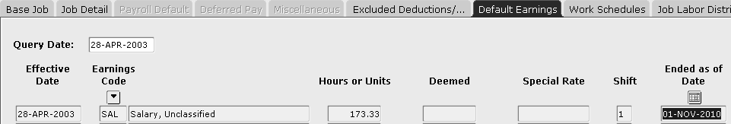

- Prior Month Termination Date:
If the termination date and the Last Paid Date for the employee are the same no further salary is due. Entering a date in the following month would cause the record to come into time entry and pay the employee through that date. You do not want this to happen.

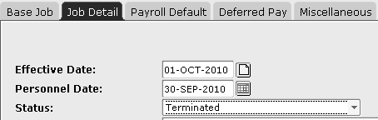
**Use this dates with Hourly employees only. Never Salaried.

You will need to terminate the record with the true termination date which is the Last Paid Date. This is the only thing you can do on this date in Banner. Remove all future dated records.
    - Example:
- Employee is terminating September 30th 2010. You are processing the form in October prior to time entry opening for October and the employee has already been paid in September. Enter a new Effective Date as 09/30/2010 and leave the Personnel Date the same. Update the status to Terminated and the change reason. Consider if there is any leave payout due. The employee has been paid salary but may have other earnings still due (vacation payout, comp payout, etc.).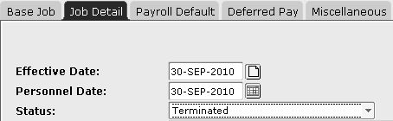

- Employee is terminating September 30th 2010. You are processing the form in October after time entry has opened for October pay. Call Central Payroll. We will determine, based on at what point in processing we are, if we can remove the record from time entry, stop the direct deposit or pull the check, or if the employee will be overpaid in October and will need collection action taken.

- Prior to Last Paid Date Termination:
When the termination date is prior to the Last Paid Date for the employee no further salary is due. By entering a date in the following month the record would come into time entry and pay the employee through that date. You do not want this to happen.

You will need to terminate the record with the Last Paid Date as the new Effective Date and change the Personnel Date to the actual last day. This is the only thing you can do on this date in Banner. Remove all future dated records.

The employee will have been overpaid. As a default pay employee they were paid for the full month and paid for days when they should have been terminated. Process an overpayment form in Oscar and send it to Central Payroll for collection.
    - Example:
- Employee is terminating September 15th 2010. You are processing the form in October and the employee has already been paid for all of September. Enter a new Effective Date as 09/30/2010 and change the Personnel Date to 09/15/2010. Change the status to Terminated and enter the change reason. This employee has been overpaid for the 16th through the 30th. Process an overpayment form for this pay.

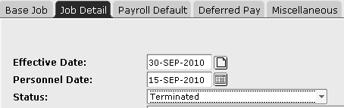

- Employee is terminating August 31st 2010. You are processing the form in October and the employee has already been paid for all of September. Enter a new Effective Date as 09/30/2010 and change the Personnel Date to 08/31/2010. Change the status to Terminated and enter the change reason.

The employee will have been overpaid for all of September. Process an overpayment form for this pay.

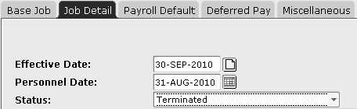

Using One Effective Date for Multiple Record Changes:

Multiple Changes on the Same Date:

- Effective Date is Already in Banner:
Sometimes you receive a job change but the effective date is already in Banner. Something else has already been processed using the same effective date of the change you are currently processing. If this date is after the Last Paid Date you can continue to make changes to that same record. Do not enter another new Effective Date. Use the record that is already there and update it with your necessary changes. While only one change reason will show all of the updates entered are recorded behind the scenes and will be reflected on the record going forward. Remember to update all future date records.
      - Example:
An employee was reappointed starting October 1st 2010. This reappointment was already processed and a new Effective Date of 10/01/2010 already exists at the time you are processing an appointment percent change which takes effect October 1st as well. In Job Detail bring up the 10/01/2010 date that already exists and enter your FTE change on that record. Update any future dates.
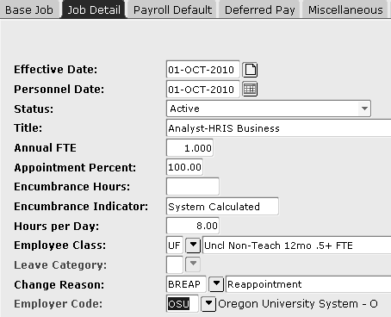
This record was added previously. You are now making a change to the record on the same effective date.
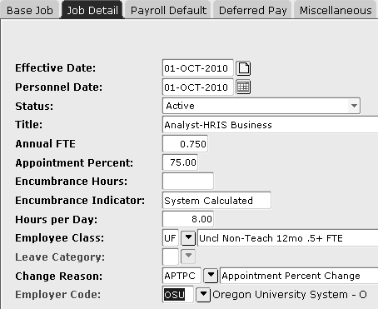
Only the last change reason entered will show but the reappointment is still saved in history.
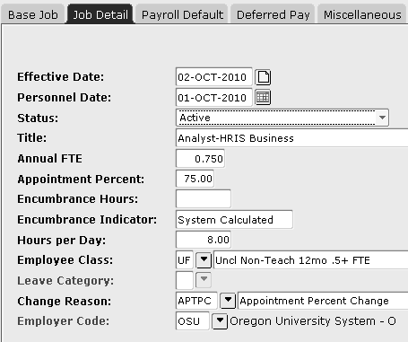
Banner will read this as the appointment percent not changing until the 2nd of the month. In time entry it would pay one day at the prior FTE and from the 2nd forward at the new FTE. The employee would be overpaid.

- Effective Date is Not Already in Banner - Future:
Sometimes multiple actions are being changed on one job form or you have multiple job forms that all require the same Effective Date. This could be a retro dated change that requires the Effective Date to be the first of the current month or a change that is truly effective the first of that month. All of the changes will be made on the same Effective Date one over the top of the other. If the changes are on separate forms, process one at a time but keep entering everything on that one Effective Date (if they truly all begin on that same date).
      - Example:
An employee has a Supervisor update and an FTE change becoming effective October 1st 2010. You are processing this form in September or prior to time entry opening for October pay. Enter a new Effective Date as 10/01/2010 and make both changes, saving each one separately. Change the supervisor and enter the Change Reason and save. Then enter the FTE change, updating the record as necessary, add that change reason and save again. Whichever Change Reason you save last will be what remains showing on the record even though multiple actions actually were updated on that Effective Date.
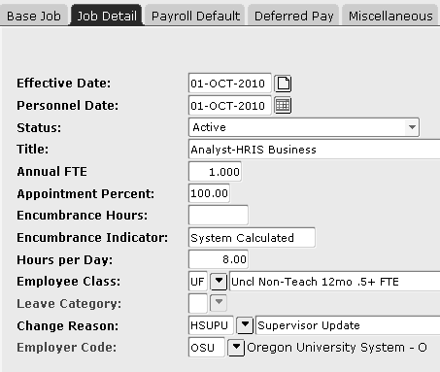

- Effective Date is Not Already in Banner – Retro and Future:
An employee has a Supervisor update that is effective retro to September 1st and an FTE change becoming effective October 1st 2010. You are processing this form after time entry has occurred in September but before October time entry has opened. First, enter a new Effective Date as 10/01/2010 and a Personnel Date of 09/01/2010 and make the supervisor update and change the Change Reason, then save that record. Then change the Personnel Date to October 1st and the FTE change making all of the necessary record updates, change the Change Reason for that update and save the record again. All saves will be recorded behind the scenes (see Job Change on a Terminated Record to learn how you can see this).

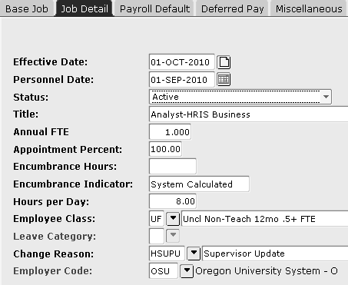

Even though you will no longer see the dates and change reason associated with the supervisor change it will be recorded and the supervisor will remain updated in future records.

  - ALWAYS update future dated records that already exist in Banner at the time of your changes (i.e termination dates, future FTE changes, other record updates that have an effective date after the one you are entering when processing the form you are currently working on.)

  - If a change should only be in effect for a specific period of time another job form needs to be made reflecting that addition change. For example if there is an FTE increase that should only be in effect for two months, another job change form needs to be made reducing the FTE effective after that two month period.

  - Once a form has been processed it is complete and whatever is received after that point replaces what came before it. If an FTE is increased it will be in effect with that increased amount until such time that another job form reduces it or the record terminates.

- Effective Date is Not Already in Banner – Retro:
If there is a retroactive change on an active record you will add the new Effective Date for the first of the current month so that the Banner record is updated for any current and future pay. You will reflect the retroactive effective date by using the Personnel Date field. Enter the date the change truly began in this field to show when the change truly should have occurred. Then you will hand calculate any additional pay that may be due or pay that was overpaid to the employee.

Making a Comment:

- Job change on a Terminated Record:
If there is a retroactive change on a terminated record you will not truly be able to update the record. You do not want to add a date in the current month as will cause pay through that date and possibly beyond if the job status is left as active. Banner will not allow the record to be changed on the Last Paid Date or prior to that date; it only allows the status to be changed to Terminated and the change reason updated.

To reflect the change you will only be able to make a note of the update. The record will have to be reflected through the change form in Nolij and you will have to hand calculate and changes in pay required (additional pay due or an overpayment).

To note the change you will use the yellow note pad directly right of the Effective Date field. Click this icon to bring up the behind the scenes records that have been saved there.

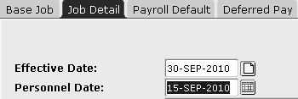

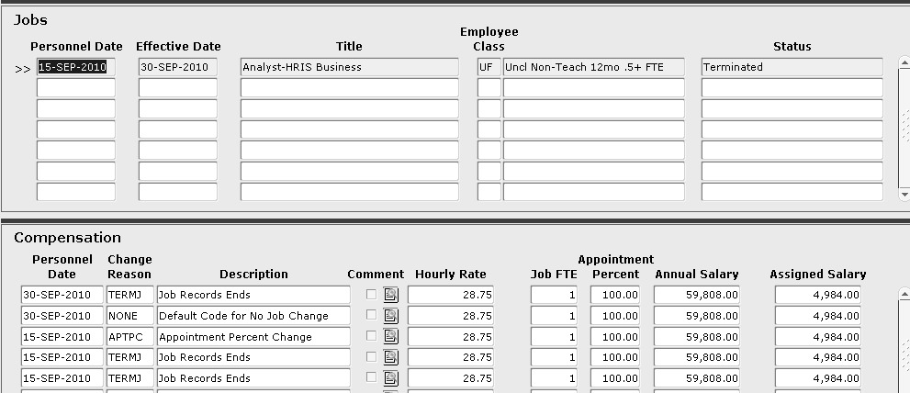

This screen records each save made on the record. This is where your changes are recorded when multiple updates are made on the same Effective Date.

Select the notepad with the magnifying glass on it next to the record you want to make a comment on.

This is the notepad with the magnifying glass.

This will bring up the detail for that record.

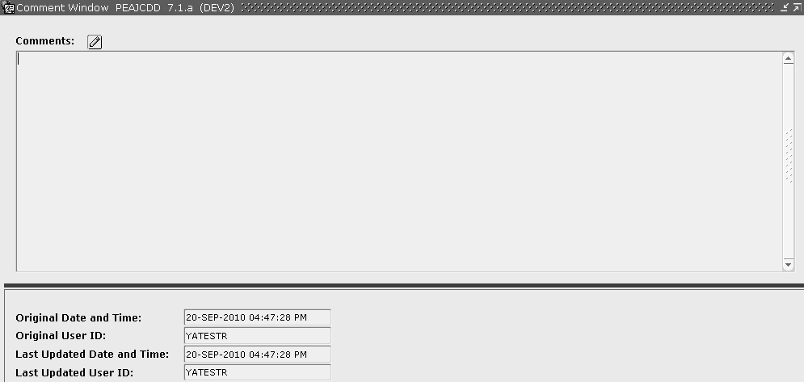
This section gives you a date stamp for the record creation or change and a ONID name for that user.
This field is blank and comments can be typed into this section and saved.

You can see that Yatestr made this record update on September 20th.

Type in your comment regarding the record update and save these changes.

      - Example:
An employee has been paid though September 30th. In October you receive a pay increase retro to September 1st. The employee terminated on September 30th and the termination was already entered so there is a termination record already in place. You need to notate that the employee’s pay increased for their final month of employment.

Select the yellow notepad icon on the termination record and the termination record within that where you will make your note. Enter your comments, save the record, and close this screen.

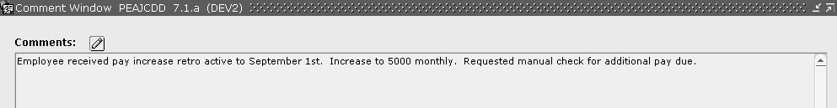

Now the yellow notepad will show writing on it indicating there is a comment on that record.

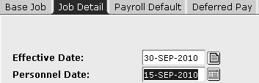
After Comment
Before Comment

If you click back on that notepad icon you will now see a check mark next to the saved record that contains a comment.
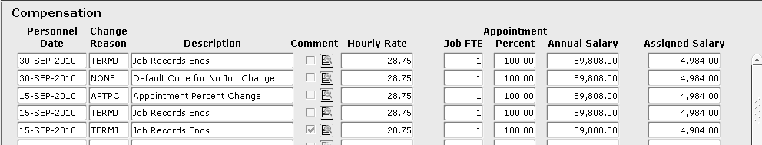
Check Mark

This function can also be used to see what date a change was made on and by whom or when multiple changes are made on the same date. In the example below you see that there was both an appointment percent change and a pay increase on this date; however on the Job Detail screen only the Change Reason for the pay increase appears.
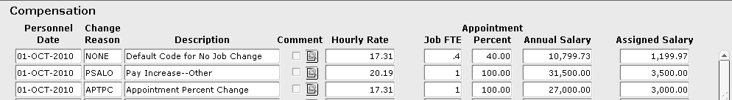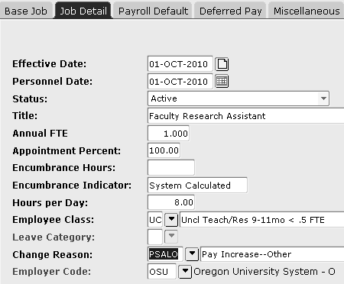

Keep in mind the last change reason you enter in the Change Reason field is the one that will display on the Job Detail record.

Consider which Change Reason would be most useful to show. This should be the one affecting pay.

For example if you have both an appointment percent change and a supervisor update the appointment percent change would be most useful to reflect on the Job Detail tab.

Record Removing:

- Removing Future Dates that No Longer Apply
Removing records can only be done when no financial information (pay or encumbrance data) has processed for that record. Be thoughtful about what records you remove. Only remove records when they are future dated records and should no longer occur.
      - Example:
An employee has resigned and their job record has a termination date in Banner for the future. You will add the new Effective Date for the termination date that is now being processed and record remove that future dated termination. If that future date is not removed Banner will pay the employee for that one day in the pay period it falls.

To remove a record move the cursor to the Effective Date in Job Detail that you want to remove. Go to the Record drop down menu and select Remove.

Drop Down Menu
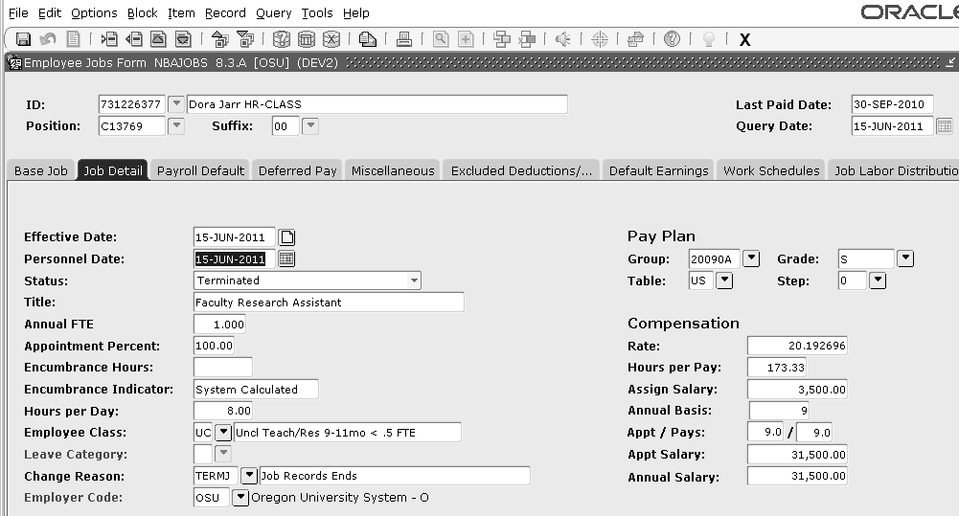

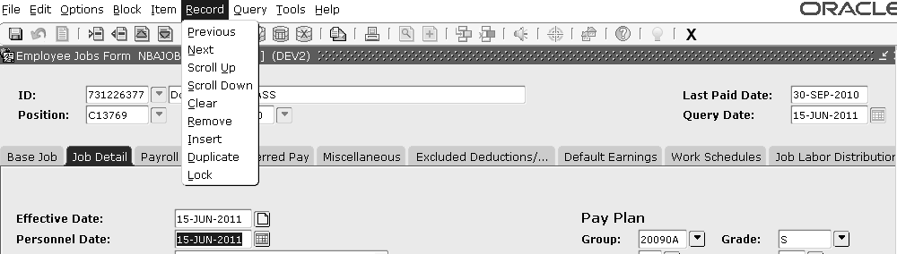

Click OK to confirm you are deleting this record.

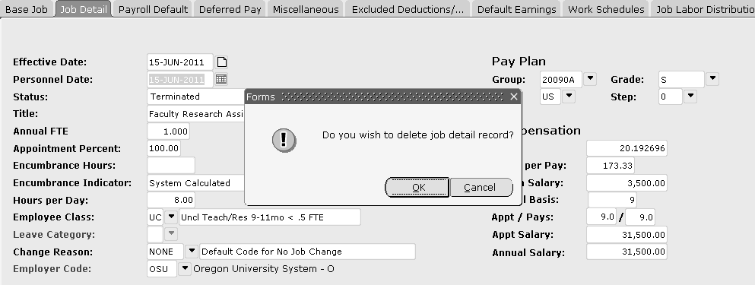

Job Detail will revert to the most recent effective date prior to the one you were removing.

Points to Remember:

- Time entry records will be reflective of the current job record, as it is, effective for that pay period. Banner uses the Effective Date, or Dates, in NBAJOBS to determine what pay reflects in PYAHOUR and prorates the records including default hours for any changes that occur within that pay period.

- Consider timing in the month when you are processing job forms. If the change reduces the amount of pay the employee will receive for that pay period CONTACT CENTRAL PAYROLL. Depending on at what point we are in the payroll processing we may still be able to update the record and correct the pay.

- Banner uses the Effective Date as the date to default information, not the Personnel Date. If the effective date is not correct the employee may be paid incorrectly. The Personnel Date is only used on retroactive changes.

- Termination dates can vary between Hourly and Salaried employees. Always consider which type of employee you are processing paperwork for and what information and dates you want to default into time entry. The system does pay through the end of the day of the record with a status of Terminated.

- Banner records all changes saved on any one new Effective Date. If you process multiple changes that require you use the same new Effective Date, process each change over the top of one another saving each. Only one Change Reason will show on the Job Detail tab in NBAJOBS but the record is recorded “behind the scenes.” Make updates to the future dated records that are already in Banner.

- Do not enter a new Effective Date on a terminated record that should stay terminated. Reflect the retroactive job changes by making a comment on the terminated Effective Date record. Use the yellow notepad icon and the magnifying glass icon to get to the comment field and add your note. Here you can also see what updates were made to the record and by whom.

- Record Remove Future Dated records that should no longer occur in the pay period they fall in.

