Extension Service
In addition to the climate action programs of colleges and universities, we conducted a national search of land grant university extension programs. All 50 states were covered. Examples pertinent to Oregon State University are found in the programs of Arkansas, California, Colorado, New Hampshire, New York, Rhode Island, and Wisconsin (Appendix D)
While there are certainly best practices occurring all over the country concerning Extension Service and their ability or mandate to provide climate change information and research to citizens, we have come to these conclusions regarding the role of extension.
- Public-private partnerships should be entered into whenever possible.
- Multi-level government partnerships have proven effective in a wide variety of political climates.
- Utilization of sustainability concepts, including the Three Pillars (Figure below), is of tantamount importance.
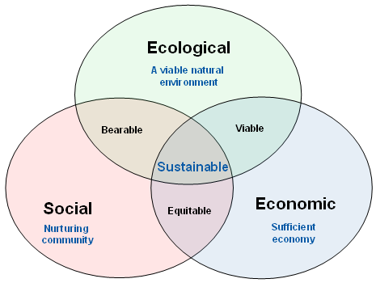
- Efforts to support and build capacity for climate change adaptation should be considered a high priority.
- Interstate communication and cooperation at the regional and national level should be considered a high priority.
- Verbiage concerning climate change has to be regionally sensitive to social and political realities.
- Gaps in funding can be met through a variety of volunteer programs, as well as extension education efforts similar to the Colorado Energy Master program.
- Top-down management efforts are to be avoided, thereby initiating local responsiveness through innovation and action.
- Adaptive management techniques can be utilized to increase stakeholder involvement. This applies to community outreach and efforts to increase community resilience activities.
University-level research into effects of climate change can be a useful tool, so long as the information is responsive to community needs, and is properly delivered to the end-user.

